Database User Guide  
  
Public Health Information eXchange (PHIX)

Version: 1.0

Prepared by:  
Science Applications International Corporation

Date: February 1, 2012

REVISION HISTORY

|  |  |  |  |
| --- | --- | --- | --- |
| Version # | Implementer | Date | Explanation |
| 0.1 | M. Trebatoski / S. Shuler / M. Marshburn | 01/27/2012 | PHIX Initial Draft – Database Guide |
| 1.0 | M. Trebatoski | 02/01/2012 | PHIX – Final Guide for Review by CDC |

Table of Contents

1.0 Introduction 8

2.0 Messaging Workbench (MWB) – Overview 9

2.1 MWB Process Flow 9

2.2 MWB Manual Update Process 10

2.3 Download and Install Messaging Workbench (MWB) Tool 10

2.4 Create a New Profile 10

2.5 Create a Data Type File for Profile 13

2.6 Create a Table File for Profile 15

2.7 Edit Table File 15

2.8 Create Library File 17

2.9 Associate Library and Table Files to Profile 21

2.10 Select Segment Libraries 22

2.11 Edit Data Types File 25

2.12 Update Library File 26

2.13 Swap Data Types 27

2.14 Export Conformance Profile 30

2.15 Import Conformance Profile 30

2.16 MWB Manual Update Process 32

3.0 Message Subscription Services – Configuration Process flow 33

3.1 Vocabulary Management 33

3.2 Vocabulary Translation 35

3.3 Vocabulary Validation 35

3.4 Configure Validation Profile 36

3.5 Configure Message Subscription 37

4.0 Message Subscription Services – Detailed Configuration and Use 40

4.1 Accessing the MSS Portal 40

4.1.1 Steps to Accessing MSS 40

4.2 Prerequisites for MSS 41

4.3 Navigation Tips for MSS 41

4.4 Vocabulary Management 42

4.4.1 Facility Management 42

4.4.2 Create a Facility 42

4.4.3 Edit a Facility 43

4.4.4 Delete a Facility 43

4.5 Code System Management 43

4.5.1 Add a Code System 43

4.5.2 Edit a Code System 44

4.5.3 Delete a Code System 44

4.5.4 Import a Code System 44

4.5.5 Export a Code System 45

4.6 Code Management 45

4.6.1 View Codes 46

4.6.2 Add Codes 46

4.6.3 Edit Codes 46

4.6.4 Delete Codes 46

4.7 Code Mapping 47

4.7.1 View Code Mapping 47

4.7.2 Map a Code 47

4.7.3 Delete a Code Map 52

4.8 Vocabulary Translation 52

4.8.1 Configure the Translation Profile 52

4.9 Vocabulary Validation 55

4.9.1 Create XPath Profile 55

4.9.2 Configure Map Field to XPath Profile 56

4.9.3 Create Map Field to Code System Profile 57

4.9.4 Create Map to Code System Profile 58

4.9.5 Configure Validation Profile 59

4.10 Message Subscription 62

4.10.1 Add a Subscriber 62

4.10.2 Edit Subscriber 63

4.10.3 Edit Subscriber 63

4.10.4 Add a Subscription 63

4.10.5 Add Subscription Criteria 64

4.10.6 Subscription Criteria Examples 65

4.10.7 Edit Subscription 66

4.10.8 Delete Subscription 66

4.10.9 Import Subscriptions 66

4.10.10 Export Subscriptions 67

LIST OF FIGURES

Figure 1. MWB Homescreen 9

Figure 2. MWB Structure List 11

Figure 3. New Message Screen (MWB) 12

Figure 4. MWB Datatype Maintenance Screen 14

Figure 5. MWB HL7 Table Search Screen 16

Figure 6. MWB HL7 Table Screen 16

Figure 7. MWB Maintain Libraries Screen 17

Figure 8. Maintain Libraries Data Displayed 18

Figure 9. Maintain Compiled Libraries Profile Screen 19

Figure 10. MWB Sample Libraries with HL7 Version Display 20

Figure 11. MWB Options Screen 21

Figure 12. MWB Active Libraries Screen 22

Figure 13. MWB Conformance Specifications Screen 23

Figure 14. Display of Selected Conformance Specifications Screen 23

Figure 15. Profile Display Screen 24

Figure 16. Display of “IN USE” Profiles 24

Figure 17. Display of Attributes for Selected Data Type 25

Figure 18. Maintain Library File Screen 26

Figure 19. Display Active Library File Screen 27

Figure 20. File – Conformance Export Screen 30

Figure 21. File – Conformance Import Screen 31

Figure 22. Conformance Profile Load Validation 31

Figure 23. MSS Dahboard Screen 41

Figure 24. MSS Vocabulary Facilities Screen 42

Figure 25. Setting a Code Systems for a Facility 43

Figure 26. Import a Code System Screen 45

Figure 27. All Code Systems Screen 45

Figure 27. View Codes for Code System Screen 46

Figure 28. View Mapped Codes Screen 47

Figure 29. Code Mapping Screen 48

Figure 30. Display of Codes based on Search Options 49

Figure 31. Display of Codes based on Selected Codes 49

Figure 32. Display of Codes based on Selected Codes with Search Options Filter 50

Figure 33. Display of Code Selection 51

Figure 34. Staged Mapping Table 51

Figure 35. Display of All Mapped Codes 52

Figure 36. Rules Configurations Screen 53

Figure 37. Rules for Profile Screen 53

Figure 38. Add New Rule Screen 53

Figure 39. Display of the Profile Window 54

Figure 40. Display of the Rule Elements 54

Figure 41. Confirmation of the Element Addition 55

Figure 42. Map Field to xPath Profile Screen 56

Figure 43. Map Field to xPath Profile Confirmation Screen 56

Figure 44. Display of XPath Keys for Profiles 57

Figure 45. Display of New XPath Key 57

Figure 46. Display of New XPath Profile 57

Figure 47. Display of Map Field to Code System Profile 58

Figure 48. Validation of Map Field to Code System Profile 58

Figure 49. Map Field to Code System Keys Screen 59

Figure 50. Add New Key Screen 59

Figure 51. Display of Map Field to Code System Profile 59

Figure 52. Display of Rule Configurations Screen 60

Figure 53. Rules for Profile Screen 60

Figure 54. Add New Rule Screen 61

Figure 55. Confirmation Screen for New Rule 62

Figure 56. MSS Subscriber List Home Page 62

Figure 57. Updated MSS Subscriber List 63

Figure 58. Create Subscription Screen 63

Figure 59. Add Subscription Criteria Screen 64

Figure 60. Verify Subscription Criteria Screen 65

Figure 61. Subscription Criteria Coded Values 65

Figure 62. Subscription Criteria Structured Numeric Values 66

Figure 63. Subscription Criteria for String Values 66

Figure 64. Export Subscription Display Screen 67

Acronym List

CDC Centers for Disease Control and Prevention

Epi Epidemiological

HAPI HL7 Application Programming Interface

ID Identification

LUNA Laboratory User Network Application

MSS Message Subscription Services

MWB Messaging Workbench

Org Organization

PHIX Public Health Information eXchange

PHLISSA Public Health Laboratory Interoperability Solutions and Solution Architecture

SOV Single Object View  
STARRS St. Louis Area Regional Response System

# Introduction

The purpose of this document is to provide an overview of the changes and component build steps that are required to configure a data exchange feed using the Public Health Information eXchange (PHIX). The driving component for the PHIX solution starts with the messages conformance profile. These profiles can be built and modified using a variety of products however, the User Guide includes instructions for defining the profile using the Messaging Workbench product. In addition, build requirements for vocabulary and code management are included as part of the build documentation.

Please note that the components of a particular message exchange and the necessary build steps will vary based on the overall use case and the standards and requirements of the messages and the data.

# Messaging Workbench (MWB) – Overview

The Messaging Workbench tool (MWB) will be utilized to complete the tasks necessary for creating conformance profiles, which are used by the HL7 Application Programming Interface (HAPI) component to validate the structure of a message that is being received by the application. Profiles are based on messaging standards, and a variety of messaging standards may exist for a specific message type, based on the specific use case of that message.

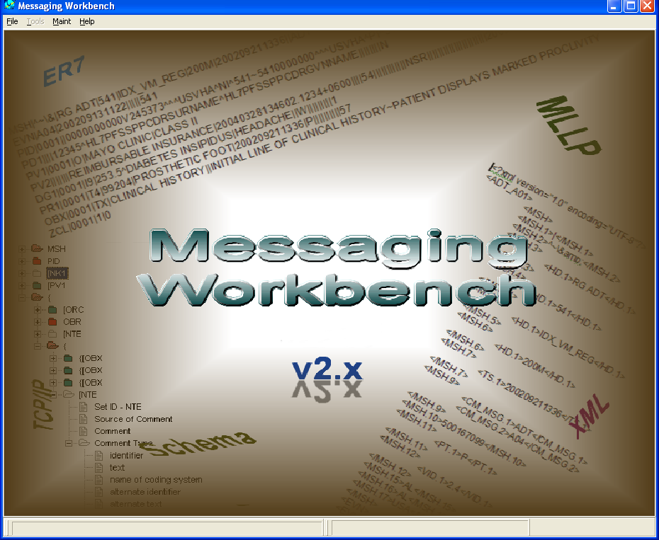

Figure 1. MWB Homescreen

## MWB Process Flow

MWB is the tool that is used to create profiles that are used to validate the structure and content of messages. Below are the different tasks involved to perform these functions:

1. Access Messaging Workbench

Run the .exe file to open Messaging Workbench (MWB)

1. Create a New Profile
2. Create a Data Type File for Profile
3. Create a Table File for Profile
4. Edit Table File
5. Create Library File
6. Associate Library and Table Files to Profile
7. Select Segment Libraries
8. Edit Data Types File
9. Update Library File
10. Swap Data Types
11. Export Conformance Profile
12. Import Conformance Profile

## MWB Manual Update Process

Manual updates to the MWB profiles may be needed due to differences between the profile created in MWB and what HAPI is expecting as well as updates to respective fields’ usage (i.e. Required, Optional, Conditional, Not Supported, etc... ) and lengths.

## Download and Install Messaging Workbench (MWB) Tool

There are several folders created when the MWB tool is installed. The Library and Project folders contain the files needed to create profiles.

* Lib - This is the library folder where the HL7 libraries, datatype definition and table files used in messaging work bench are stored. These files can be distinguished by the file extension. Library - .mcf; data type - .mdf files and tables - .mwt.
* Projects - This is the project folder where the profiles used in messaging work bench are stored. These files will have an extension of .mwb.
* Run the .exe file to open Messaging WorkBench (MWB)

## Create a New Profile

1. Click on File tab.
2. Select Change Structure List.
3. Select the Version number for the Structure being created .(e.g. 2.5.1)
4. Select Load Msg Structure.

The MWB Msg Structure Select window is displayed.

* The Show option defaults to Struct and Desc.
* The structures available for the HL7 version selected from the Structure List are displayed.

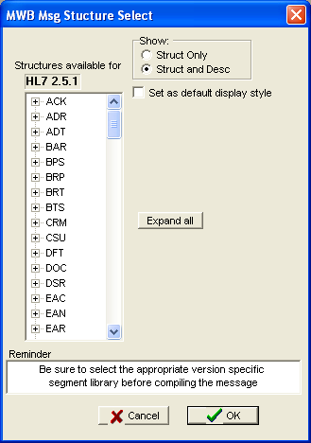

Figure 2. MWB Structure List

1. Select the Message Structure type from the list of available structures. (e.g. ORU)
2. Expand the structure.
3. Select the Message Structure. (e.g. ORU^R01)
4. Select OK.

The selected structure is loaded into MWB.

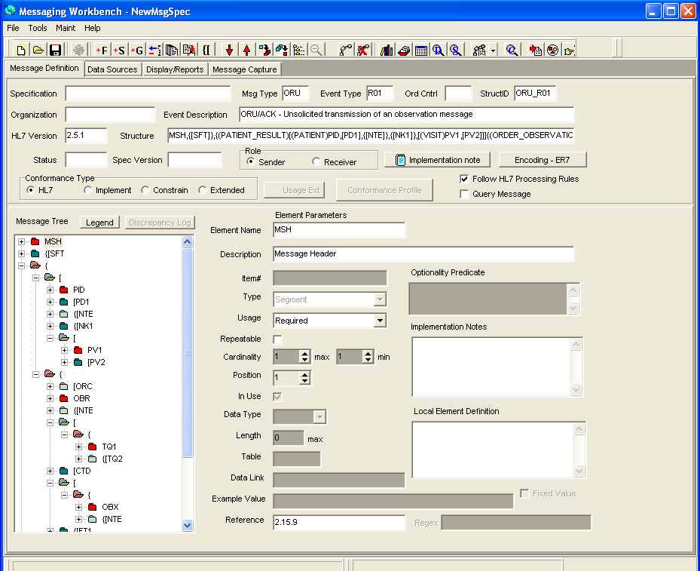

Figure 3. New Message Screen (MWB)

1. Enter appropriate information in the following fields:

* Specification – enter the name you want to use for the profile.
* Organization Name – enter your organization name.
* Status – enter the status of the profile. (e.g. Draft, Final)
* Spec Version – enter the version of the specification document being used to constrain the profile.

**Note:** There are four options for Conformance type: HL7, Implement, Constrain and Extended. The profiles created for this project will be constrained to a specific implementation guide; therefore, Constrain is selected for the conformance type.

1. Click the radio button for the Role of the profile. The default is Sender. (e.g. Sender, Receiver)
2. Click on the Constrain radio button.
3. Highlight all of the elements in the list of discrepancies.

**Note:** This is the list of elements that are maintained for backward compatibility.

1. Select the appropriate usage for the selected elements. (e.g. Optional)
2. Click the **Make Change** button.
3. Click the Close button after the changes are complete. (i.e. no elements listed in the window)
4. Update the Usage, Repeatable and Cardinality fields for each segment and segment group to reflect constraints specified in the implementation guide.
5. Update the Field level information for each field within the segments to reflect constraints specified in the implementation guide. This would include usage, repeatable, cardinality and/or length for the fields.
6. Select Save As from the File tab.

**Note:** The file name is set as the value entered in the Specification field concatenated with the message structure. (e.g. ELR Test Profile-ORU_R01). You can change this to something different if needed. The profile will be saved in the Projects folder.

## Create a Data Type File for Profile

The data type file has the data types that will be used in the profile. The components attributes are defined for each data type and can be modified to support the specifications as defined in the implementation guided.

1. Open MWB.
2. Select the Maint tab.
3. Select Datatypes >Add/Edit Datatype File.
4. Click the File tab.
5. Click Open.
6. Select the datatype file for the profile. (e.g. DT2-5-1.mdf)

**Note:** The HL7 standard datatype files for each version are stored in the Lib folder.

1. Click Open.

**Note:** The selected version is displayed in the MWB Datatype Maintenance window.

1. Click on the Data Type tab.

**Note:** The attributes of the data types can be modified in this tab.

1. Select Edit > <select the data type to be edited>. (e.g. Edit > CE)

The attributes for the selected data type are displayed.

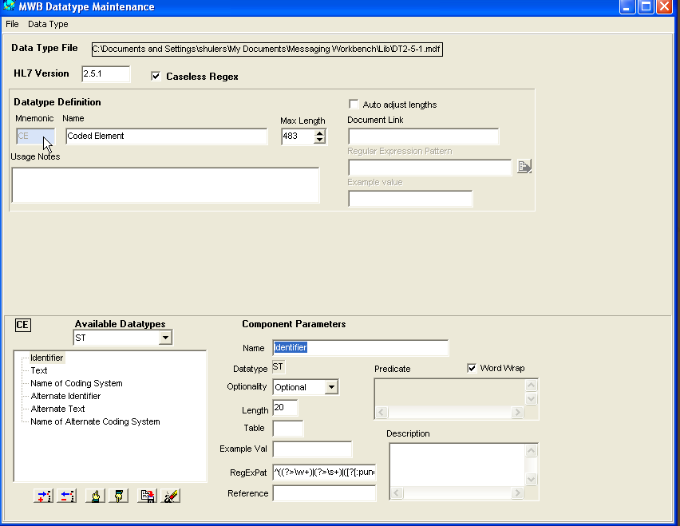

Figure 4. MWB Datatype Maintenance Screen

1. Update the Optionality and/or length attributes as needed.
2. Click on the Save Data Type icon.
3. Repeat steps 9 – 11) for each datatype that requires changes.
4. Select Save As from the File tab and save the file with a different name. The file name should correspond with the profile that will be associated with the datatype file. (e.g. ELR Test Profile Datatypes_251.mdf)
5. Close the MWB Datatype Maintenance window.

**IMPORTANT:** Do not save the file with the name of any of the existing HL7 data type files as this will override the standards that are included in the Lib folder when MWB is installed. These should always remain the same to use as the starting point to create new data type files to support specific profiles.

## Create a Table File for Profile

The table file has the tables that will be used in the profile. The components attributes are defined for each table and can be modified to support the specifications as defined in the implementation guided.

1. Access the MWB Lib folder.

**Note:** The HL7 standard table files for each version are stored in the Lib folder.

1. Select the table file for the profile. (e.g. HL7TableFile251.mwt)
2. Right click on the file and select Copy.
3. Right click and select Paste.

**Note:** This will paste a copy of the selected table in the Lib folder.

1. Rename the table file.

**Note:** The file name should correspond with the profile that will be associated with the table file. (e.g. ELR Test Profile Tables_251.mdf)

**IMPORTANT:** Do not save the file with the name of any of the existing HL7 table files as this will override the standards that are included in the Lib folder when MWB is installed. These should always remain the same to use as the starting point to create new table files to support specific profiles.

## Edit Table File

1. Open MWB.
2. Select the Maint tab.
3. Select HL7 Tables > Add/Edit/Delete Table Elements.
4. Click the Select Tables File button.
5. Select the table file for the profile. (e.g. HL7TableFile251.mwt)

The HL7 Table window is displayed for the selected table with options to search for tables by entering/selecting values for the Table, Name, Type or Code System.

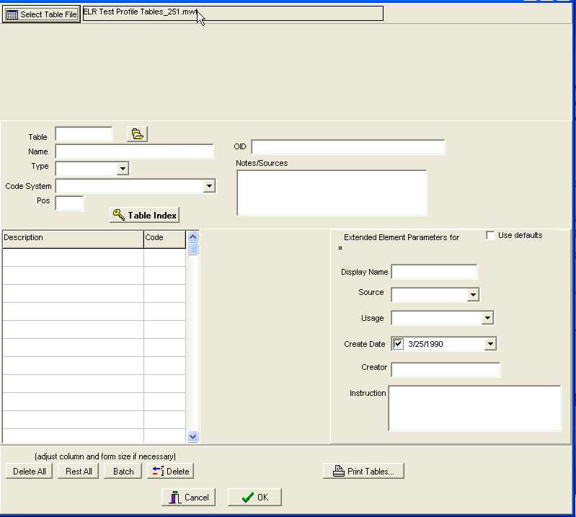

Figure 5. MWB HL7 Table Search Screen

1. Enter a table number in the Table field.
2. Click the Open Table icon.

The values for the selected table are displayed.

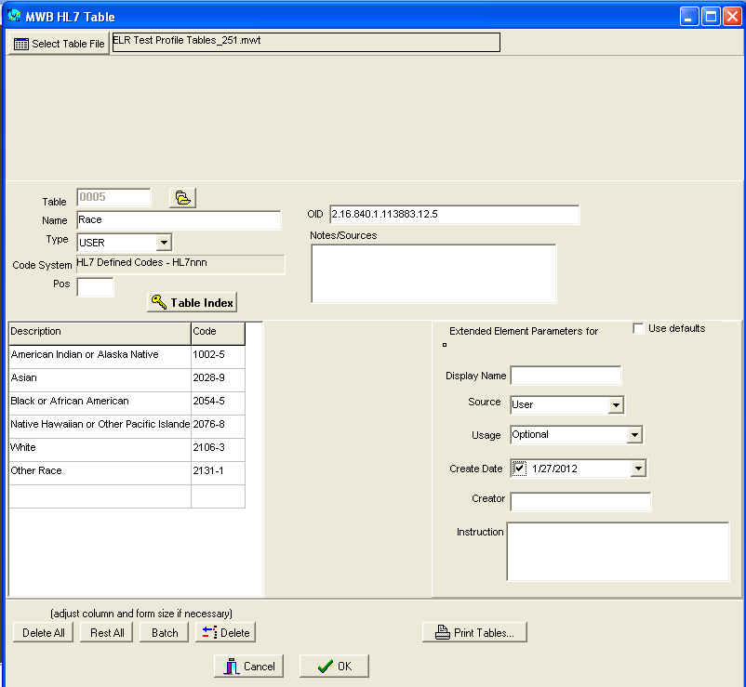

Figure 6. MWB HL7 Table Screen

1. Add/Edit/Delete codes as needed.
2. Click the OK button.
3. Select ‘Yes’ in the Confirm window if you want to edit another table; otherwise select ‘No’.

## Create Library File

You must load the Profile into MWB before you can create the library file.

1. Open MWB.
2. Select File > Open.
3. Select the Profile from the Projects folder. (e.g. ELR Test Profile-ORU_R01.mwb)
4. Click Open. The Profile is loaded.
5. Click on the Maint tab.
6. Select Libraries > New Library File.

The MWB Maintain Specifications Libraries window displays.

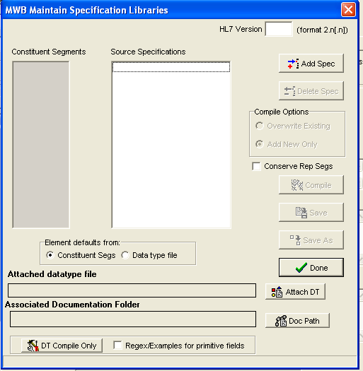

Figure 7. MWB Maintain Libraries Screen

1. Enter the version number in the HL7 Version field. (e.g. 2.5.1)
2. Click on the Add Spec button.
3. Select the conformance Profile. (e.g. ELR Test Profile-ORU_R01.mwb)
4. Click on the Attach DT button.
5. Select the Data Type file. (e.g. ELR Test Profile Datatypes_251.mdf)
6. Click Open.
7. Click on the Doc Path button.
8. Click OK.

The information enter/selected is displayed in the appropriate fields.

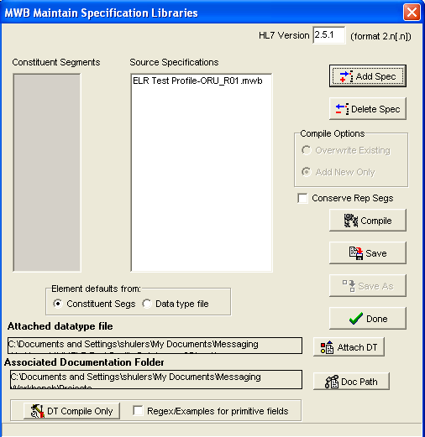

Figure 8. Maintain Libraries Data Displayed

1. Click on the Compile button.

The system displays message *Compiling library File* message.Once the library is compiled, the system will flashes the message *Associating DT to library file.* When the process is complete, the segments associated with the profile are listed in the Constituent Segments pane.

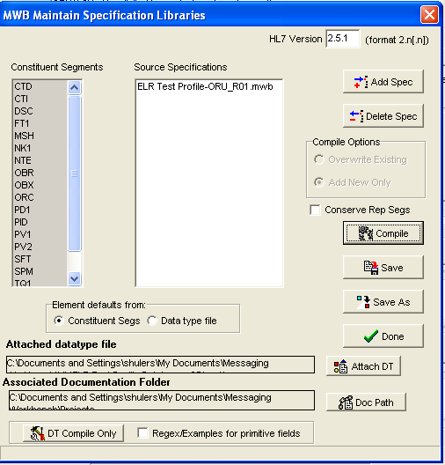

Figure 9. Maintain Compiled Libraries Profile Screen

1. Click on the Save As button.
2. Enter a file name for the library file. (e.g. ELR Test Profile Library_251)
3. Save as .mcf type. ( saves as ELR Test Profile Library_251.mcf)

The name of the library is displayed in the box preceding the HL7 version

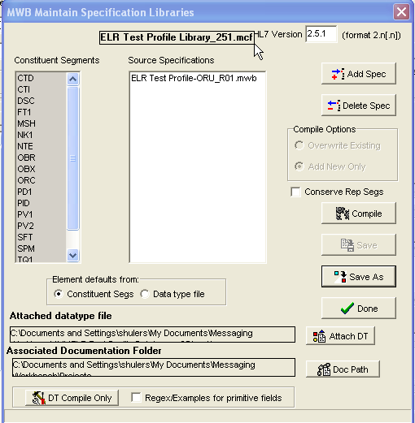

Figure 10. MWB Sample Libraries with HL7 Version Display

1. Click on the Done button.

## Associate Library and Table Files to Profile

You must load the Profile into MWB before you can create the library file.

1. From MWB tool, click on the Maint tab.
2. Click Options.
3. Click on the browse button under the Select Default Conformance File area.
4. Locate and select the Library file. (e.g ELR Test Profile Library_251.mcf)
5. Click Ok.
6. Click on the browse button under the HL7 Table file area.
7. Locate and select the Table file. (e.g ELR Test Profile Tables_251.mwt)
8. Click OK.

The selected Library and Table are displayed

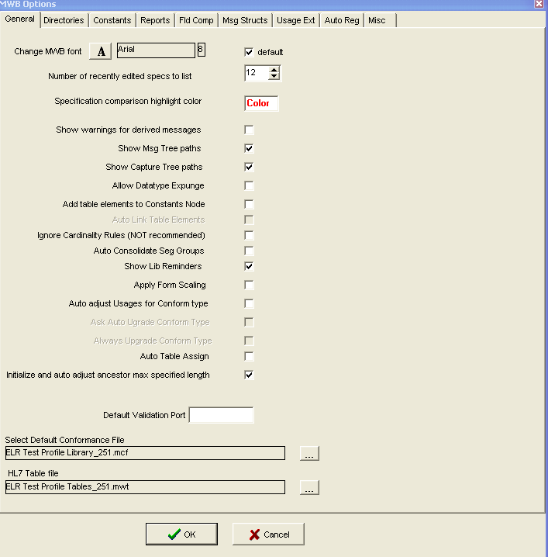

Figure 11. MWB Options Screen

1. Click the Ok button.

## Select Segment Libraries

You must load the Profile into MWB before you can create the library file.

1. From MWB tool, click on the Select active libraries icon in tool bar. (books)

**Note:** Name of action displays when you scroll over icon.

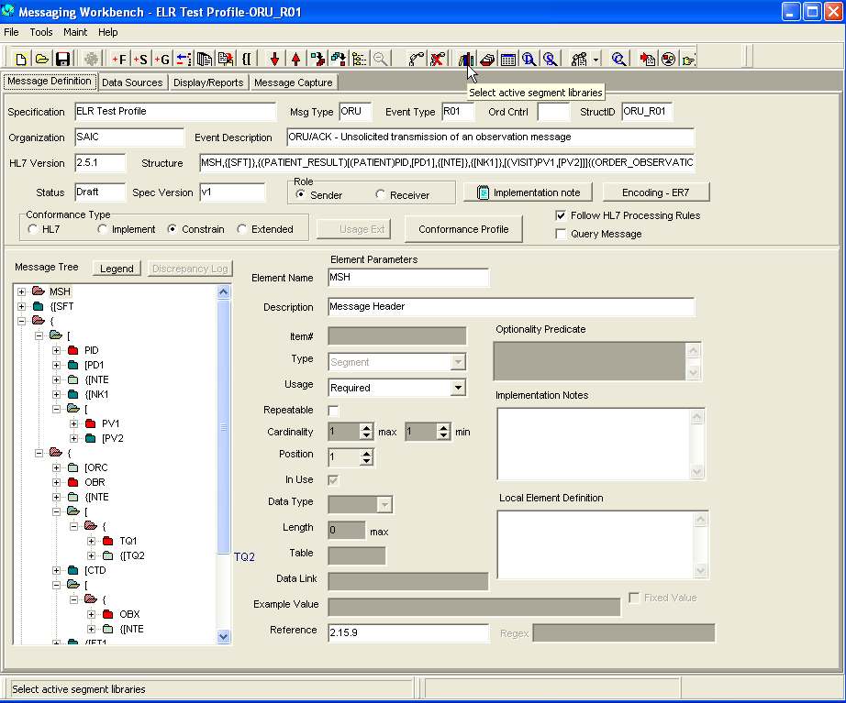

Figure 12. MWB Active Libraries Screen

The MWB Select Conformance Specifications window is displayed with the list of available Library Files (left) and current active Prioritized Conformance files.

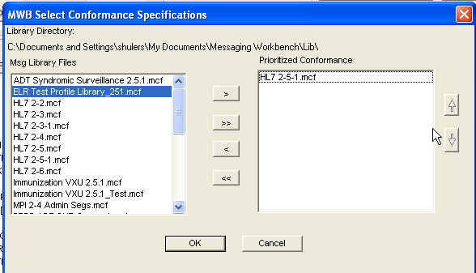

Figure 13. MWB Conformance Specifications Screen

1. Select the desired library from the list on the left. (e.g. ELR Test Profile Library_251.mcf)
2. Click the move arrow (>) to add file to active Prioritized Conformance list on right.
3. Click on a file in the list of Prioritized Conformance files; the click the remove arrow (<) to move to a file to the non-active list on left.

The files are moved as selected.

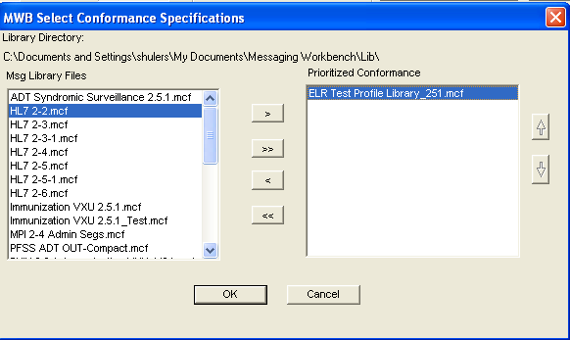

Figure 14. Display of Selected Conformance Specifications Screen

1. Click OK.
2. Select the Show Active Libs icon in tool bar.

**Note:** Name of action displays when you scroll over icon.

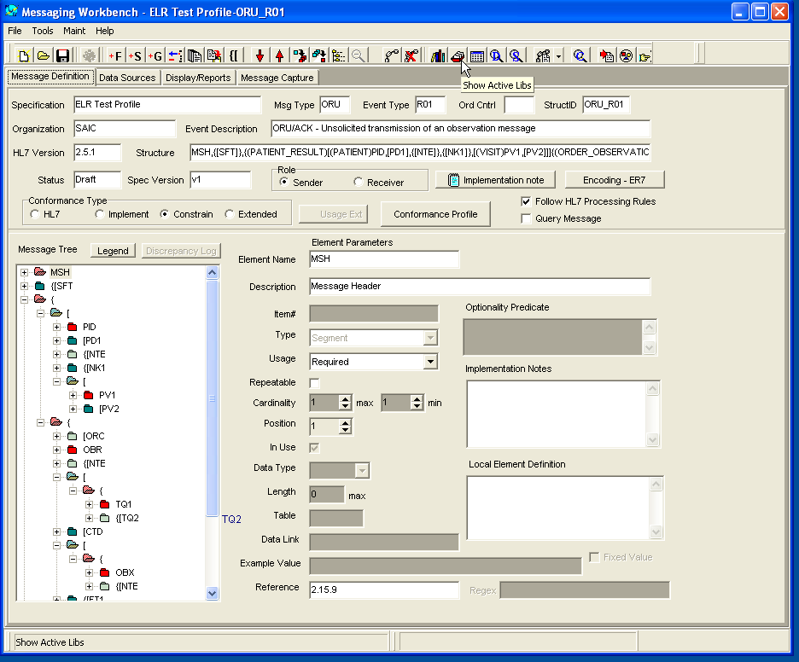

Figure 15. Profile Display Screen

The library, data type and table files that are currently in use are displayed.

**Note:** These are the files that were created for the profile

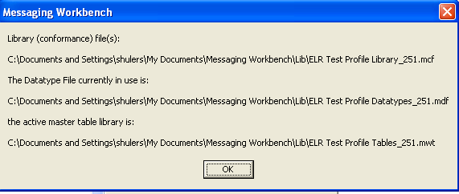

Figure 16. Display of “IN USE” Profiles

1. Click OK. The window closes.
2. Click on the Save icon to save the changes to the Profile.

## Edit Data Types File

1. Open MWB.
2. Select the Maint tab.
3. Select Datatypes >Add/Edit Datatype File.
4. Click the File tab.
5. Click Open.
6. Select the datatype file for the profile. (e.g. ELR Test Profile Datatypes_251.mdf)
7. Click Open.
8. Click on the Data Type tab.
9. Select Edit > <select the data type to be edited>. (e.g. Edit > CE)

The attributes for the selected data type are displayed



Figure 17. Display of Attributes for Selected Data Type

1. Update the Optionality and/or length attributes as needed.
2. Click on the Save Data Type icon.
3. Repeat steps 9 – 11) for each datatype that requires changes.
4. Select Save in File tab.

System displays reminder message.

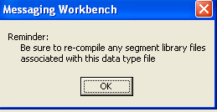

1. Click Ok. Window closes.

## Update Library File

The Library file must be updated anytime changes are made in the data types file. You must load the Profile into MWB before you update the library file.

1. Open MWB.
2. Select File > Open.
3. Select the Profile from the Projects folder. (e.g. ELR Test Profile-ORU_R01.mwb)
4. Click Open. The Profile is loaded.
5. Click on the Maint tab.
6. Select Libraries > Edit Library File.
7. Select the library file from the Lib folder. (ELR Test Profile Library_251.mcf)
8. Click Open.

The MWB Maintain Specifications Libraries window displays showing the information for the selected library file

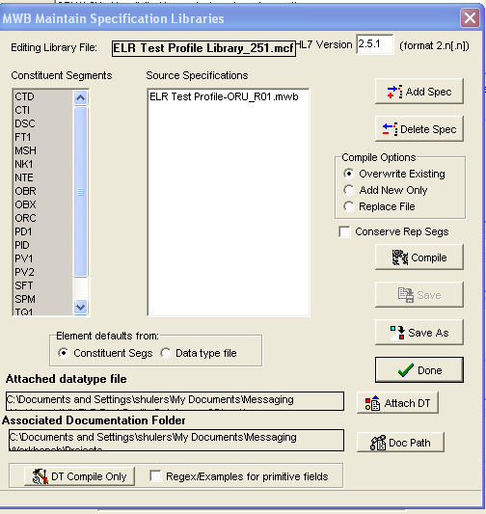

Figure 18. Maintain Library File Screen

1. Click on the DT Compile Only button at bottom of window.

Note: The system displays message *Compiling Library File* message.Once the library is compiled, the system flashes the message *Associating DT to library file.*

1. Click on the Save button
2. Click on the Done button.

## Swap Data Types

The Swap Data Types function is utilized after making changes to the Data Type file and re-compiling the library file. You must load the Profile into MWB before you swap data types.

**IMPORTANT:** Always click on the Show Active Libraries icon to verify the correct library, data type and table files show as currently in use.

1. Select the Show Active Libs icon in tool bar. (red folder)

**Note:** Name of action displays when you scroll over icon.



Figure 19. Display Active Library File Screen

The library, data type and table files that are currently in use are displayed



1. Click OK. The window closes.

**Note:** If the **incorrect** files show as currently in use; follow the steps in Section 2.7 to select the correct library file. The data type and table files are linked to the library file; therefore, you do not have to select these as active files.

1. Select the Maint tab.
2. Select Datatypes >Swap Datatype.

The MWB Swap Data Types window displays.

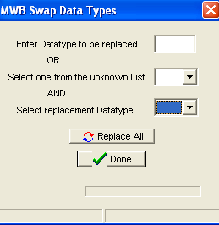

1. Enter Data Type to be replaced in the Datatype box.

**Note:** Enter a data type that was edited.

1. Select the same datatype from the Select replacement Datatype dropdown.

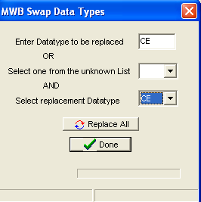

1. Click the Replace All button.

**Note:** The old attributes of the selected datatype will be replaced with the updated attributes.

After the swap is complete, the system displays the number of changes that resulted from the datatype swap.

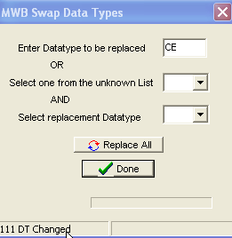

1. Repeat these steps 5 – 7 to swap other datatypes.
2. Click the Done button after finishing all datatype swaps.
3. Click the Save icon to save the profile.

**TIP:** Look at some of the fields that have the data type as those that were swapped to make sure the new attributes show for the datatypes.

## Export Conformance Profile

You must load the Profile into MWB before you swap data types.

1. Open MWB.
2. Select File > Open.
3. Select the Profile from the Projects folder. (e.g. ELR Test Profile-ORU_R01.mwb)
4. Click the file tab.
5. Select Export HL7 Conformance Profile.

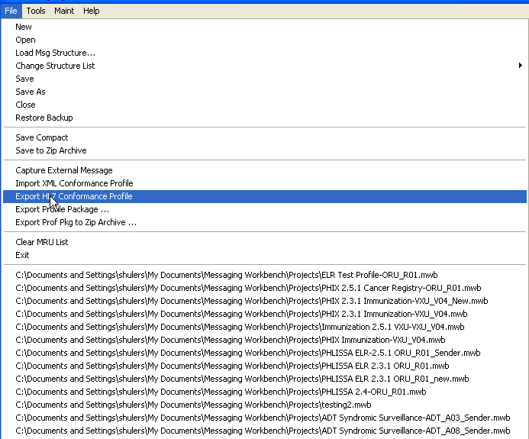

Figure 20. File – Conformance Export Screen

1. Save the file with an .xml extension. (e.g. ELR Test Profile-ORU_R01.xml)

**Note:** the file is saved in the Projects folder.

## Import Conformance Profile

1. Open MWB.
2. Click the file tab.
3. Select Import XML Conformance Profile.

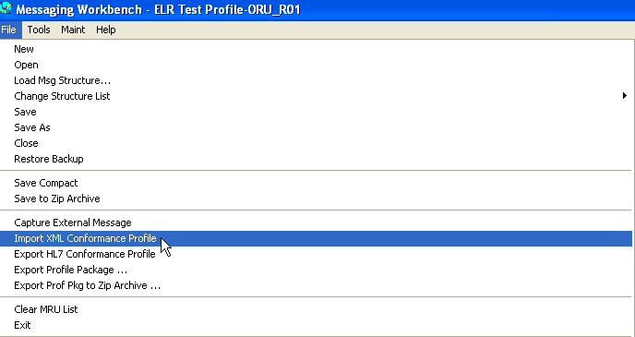

Figure 21. File – Conformance Import Screen

1. Select the conformance profile from the Projects folder. (e.g. ELR Test Profile-ORU_R01.xml)
2. Click Open.

The profile is loaded into MWB

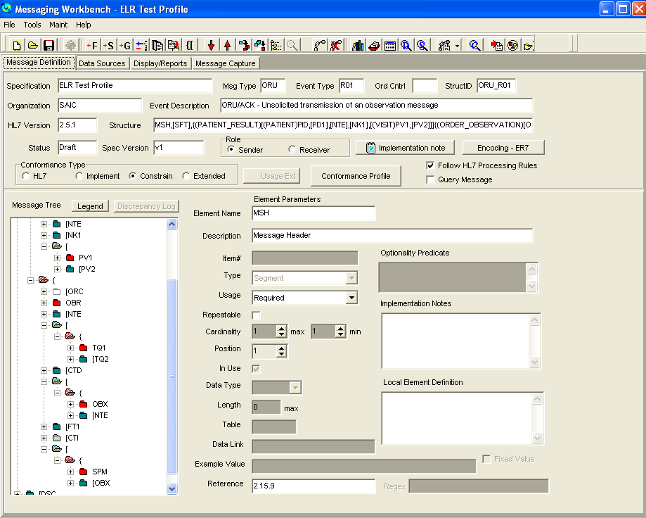

Figure 22. Conformance Profile Load Validation

## MWB Manual Update Process

Manual updates to the MWB profiles may be needed due to differences between the profile created in MWB and what HAPI is expecting as well as updates to respective fields’ usage (i.e. Required, Optional, Conditional, Not Supported, etc... ) and lengths.

# Message Subscription Services – Configuration Process flow

The following provides a high level overview of the tasks and requirements for configuring the MSS components of PHIX. For additional information related to the individual task details, please refer to section 4.0 of this guide.

## Vocabulary Management

Vocabulary management allows the ability to support and validate code values based on criteria defined within the message and the required message output.

1. **Add a Facility**
2. Click Validation or Translation bar in the navigation pane
3. Expand Vocabulary Folder
4. Click Facilities link
5. Click create button
6. Enter required information in the Add New Facility window
7. Click create
8. **Add Code System**
9. Click Validation or Translation bar in the navigation pane
10. Expand Vocabulary Folder
11. Click Facilities link
12. Click on name of the Facility link from the Facilities List page
13. Click create button
14. Enter required information in the Add New Code System window
15. Click create
16. **Add Codes**
17. Click Validation bar in the navigation pane
18. Expand Vocabulary Folder
19. Click Facilities link
20. Click on name of the Facility link from the Facilities List page
21. Select the coding system
22. Click create button
23. Enter the Name and description for the code in the Add New Code window
24. Click create
25. **Map a Code**
26. Click Validation bar in the navigation pane
27. Click on Map codes link under Vocabulary
28. Select Facility from dropdown
29. Select Coding System on left for Codes 1 (e.g. name of the Local code system )
30. Select the code to be mapped (code is displayed in the Selected Codes area)
31. Select Coding System on right for Codes 2
32. Search for code (e.g. 630-4)
33. Select the code 2 (codes is displayed in the selected Codes area)
34. Click Add Mapping (codes move to Staged mapping area below the code list)
35. Click Save Mappings
36. Click OK to message Mapping Saved Successfully

**Note:** Repeat these steps to map additional codes.

1. **Export a Code System**

You export code systems using the All Code Systems link.

1. Click on the Translation or Validation bar in the navigation pane
2. Expand Vocabulary folder
3. Click All Code Systems link
4. Select one of the two export options:

* Click the Export Code Systems button to export only the selected Facilities, Code Systems, and Codes.
* Click the Export Mappings button to export the selected Facilities, Code Systems, Codes, and any associated mappings.

1. Click on the checkbox for the code system(s) to export
2. Click Export button
3. Click Yes to the export confirmation
4. **Import Subscriptions**

You export code systems using the All Code Systems link.

1. Click on the Translation or Validation bar in the navigation pane
2. Expand Vocabulary folder
3. Click All Code Systems link
4. Click Import button
5. Click Select File button and navigate to file to be imported
6. Click Import Subscription (s)

## Vocabulary Translation

Vocabulary Translation function provides the capability to perform code translation tasks to allow mapping between vocabularies and mapping of local codes to standard codes.

1. **Create Translation Profile**
2. Click on the Translations bar in the navigation pane
3. Expand Translation folder
4. Click Profile link
5. Click create button
6. Enter the Name and description for the validation profile in the Add a Profile window.
7. Click create
8. **Configure Translation Profile**
9. Click on the Translations bar in the navigation pane
10. Expand Translation folder
11. Click Profile link
12. Click on name of the Profile link from the Rule page
13. Click create button
14. Enter Name for rule (e.g. OBX3)
15. Check the Use Short Name box
16. Click create
17. Click on the rule name (e.g. OBX3)
18. Click create
19. Enter Value in box (field path e.g. //OBX-3); enter description
20. Click create
21. Click Update Translation Service link

## Vocabulary Validation

Vocabulary Validation function provides the capability to perform field-level validation tasks and validate message elements against a code systems and/or a value sets maintained by PHIN VADS.

1. **Create XPath**
2. Click on the Validation bar in the navigation pane
3. Expand the *Map Field To XPath* folder
4. Click the Profiles link
5. Click create button
6. Enter the Name and description for the validation profile in the Add a Profile window.
7. Click create
8. Click Update Validation Service link
9. **Configure Map Field to XPath Profile**
10. Click on the Validation bar in the navigation pane
11. Expand the *Map Field To XPath* folder
12. Click the Profiles link
13. Click on the name link for the XPath profile
14. Click create button
15. Enter the required information in the Add New Key window
16. Click create
17. **Create Map Field to Code System Profile**
18. Click on the Validation bar in the navigation pane
19. Expand the *Map Field To Code System* folder
20. Click the Profiles link
21. Click create button
22. Enter the required information in the Add New Key window
23. Click Create
24. **Configure Map to Field Code System Profile**
25. Click on the Validation bar in the navigation pane
26. Expand the *Map Field To Code System* folder
27. Click the Profiles link
28. Click on the name link for the code system profile
29. Click create button
30. Enter the required information in the Add New Key window
31. Click create
32. Click Update Validation Service link

## Configure Validation Profile

Validation Profile must be created in order to create validation rules.

1. **Create Validation Profile**
2. Click on the Validation bar in the navigation pane
3. Expand Validation folder
4. Click Profile link
5. Click create button
6. Enter the Name and description for the validation profile in the Add a Profile window.
7. Click create
8. **Configure Validation Profile**

Rules for OBX-3 will be created for this demonstration

1. Click on the Validation bar in the navigation pane
2. Expand Validation folder
3. Click Profile link
4. Click on name of the validation profile link for the rule
5. Click create button
6. Select **phlissa-path** (name of the XPath profile you created) from the Element Value Profile drop down.
7. Select **OBX-3.1** from the Element Value Key drop down.
8. Select **PHINVADS** for the Source option.
9. Select **Error** for the Issue Level option.
10. Select **All** for the Check Repeating option.
11. Select **Code System** for the Program Area Scope option.
12. Select **phlissa-cs** (name of the Code system profile you created) from the Program Area Profile drop down.
13. Select **OBX-3.1** from the Program Area Key drop down.
14. Click Create
15. Click Update Validation Service link

## Configure Message Subscription

Message Subscription function provides the capability to perform message routing tasks based on criteria specified to direct when and where messages are delivered.

1. **Add a Subscriber**
2. Click on the Subscriptions bar in the navigation pane
3. Expand Subscription Management folder
4. Click Subscribers link
5. Click Create button on the Subscribers List page
6. Enter the Subscriber Name and Address in the Add New Subscriber window
7. Click Create.
8. The subscriber is added to the Subscriber list
9. **Add a Subscription**
10. Click on the Subscription bar in the navigation pane
11. Expand Subscription Management folder
12. Click Subscribers link
13. Click on the name link for the subscriber
14. Click Create button
15. Enter the Subscription Name and Description
16. Click Create Subscription
17. **Add Subscription Criteria**
18. Click on the Subscription bar in the navigation pane
19. Expand Subscription Management folder
20. Click Subscribers link
21. Click on the name link for the subscriber
22. Click on the name link for the subscription
23. Click Create button
24. Enter the Subscription criteria
25. Click Create
26. **Export Subscriptions**

You can import subscriptions from the Subscribers or Subscription page.

1. Click on the Subscription bar in the navigation pane
2. Expand Subscription Management folder
3. Click Subscribers link
4. Select one of the two export options:
5. To export a single subscription, click the subscriber link for the Subscriber that contains the subscription you wish to export.
6. To export all subscriptions assigned to a subscriber, displays the *Subscriber* List page.
7. Click on the checkbox for the Subscriber (s) or subscriptions (s) to export
8. Click Export button
9. Click Yes to the export confirmation
10. **Import Subscriptions**

You can import subscriptions from the Subscribers or Subscription page.

1. Click on the Subscription bar in the navigation pane
2. Expand Subscription Management folder
3. Click Subscribers link
4. Click Import button
5. Click Select File and navigate to file to be imported
6. Click Import Subscription (s)

# Message Subscription Services – DETAILED Configuration and Use

Messaging Subscription Service (MSS) is set of applications that perform various electronic messaging and data interchange tasks to support public health functions. The functionalities for performing the tasks for Vocabulary Translations, Vocabulary Validation and Message Subscriptions will be covered in this documentation. These are high level instructions provided in this document. PHIX users are directed to refer to the MSS User Guide for more detailed instructions.

## Accessing the MSS Portal

You can access the MSS Portal if you have been given rights by the MSS System Administrator. You must be on the network where the environment is set up in order to use remote desktop connection to login to the portal. MSS Administration Portal v3.6 is the current version of the tool.

### Steps to Accessing MSS

1. Type the URL for *MSS Dashboard* Login page

The default URL is **[Error! Hyperlink reference not valid.](http://[mss_server]:8080/mssportal)**. (replace [mss_server] with your MSS server name.

1. Enter username and password
2. Click Login

This will take you to the MSS Dashboard. The available tasks are located at the bottom of the navigation pane.

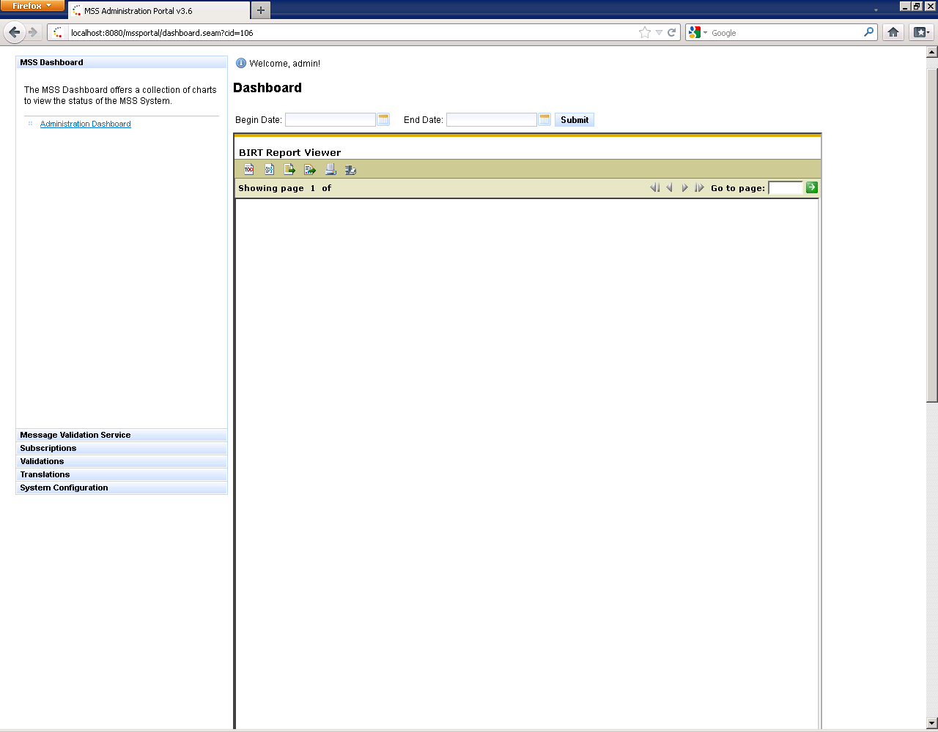

Figure 23. MSS Dashboard Screen

## Prerequisites for MSS

Before you begin setting up the services in MSS, you must collect some preliminary information.

* Facility ID – this is the value that will be used to identify the sending facility that will be populated in the sending facility field (MSH-4.2) of the messages being processed.
* Local/Standard Codes – this is a list of the local codes along with the corresponding standard code to use for mapping local to standard codes.
* Fields to validate – this is a list of the fields that will require validation against a specific coding system or value set.

## Navigation Tips for MSS

* To display the *Vocabulary Management* page, click on either the click the Validations or Translations bar; then click the Facilities link from the Vocabulary folder.
  + To display the *Code Systems* list page, click the Facility link of the facility you want to display from the All Facilities list page.
  + To display the *Codes* list page, click the code system of the codes you want to display from within the Code Systems list page.
* To display the *Vocabulary Translation Management* page, click on the Translation bar; then click the Profile link from the Translation folder.
  + To display the *Rules for Profile* list page, click the Facility link of the facility you want to display from the Rule Configurations list page.
  + To display the *Elements for Rule* list page, click the rule you want to display from within the Rule for Profile list page.
* To display the *Subscription Management* page, click the Subscribers link from the Subscription Management folder from within the Subscriptions Bar.
  + To display the *Subscriptions for Subscriber* list page, click the Subscription link of the subscription you want to display from the Subscribers list page.
  + To display the *Criteria for Subscription* list page, click the subscription you want to display from within the Subscriptions for Subscriber list page.

**Important:**

* You must click on the ***Update Translation Services*** link in the navigation pane after making changes in code translations in order for the codes to be immediately updated in the data base.
* You must click on the ***Update Validation Services*** link in the navigation pane after making changes in code validation in order for the changes to be immediately updated in the data base.

## Vocabulary Management

The Vocabulary Management List page displays all Facilities, enabling you to create, delete and edit Facilities.

### Facility Management

To display the Vocabulary Management List page, click on the Validations or Translations bar from the Navigation Pane; then click on the Facilities link from the Vocabulary folder.

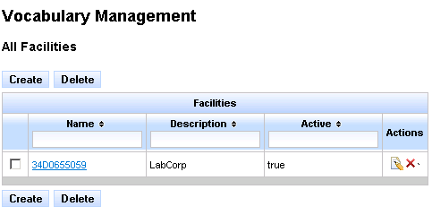

Figure 24. MSS Vocabulary Facilities Screen

### Create a Facility

1. Click on the Create button.
2. Enter the Facility Name and description in the Add New Facility window.

Note: The Facility Name should be populated with the value in the sending facility field (MSH-4.2) in the messages.

1. Click Create. The facility is created.

### Edit a Facility

1. Click on the edit icon (note pad/pencil) under Actions.
2. Edit the necessary information in the Edit Current Facility window.
3. Click Update. The facility is updated.

### Delete a Facility

1. Click on the delete icon (red **X**) under Actions to delete one facility at a time.

**Note:** To delete several facilities at one time, check the box next to all the facilities to be deleted and then click the Delete button.

1. Click Yes in the Delete confirmation window. The facility is deleted.

## Code System Management

Click the ***Facility*** link from the Facilities List Page for the Code System(s) you want to display.

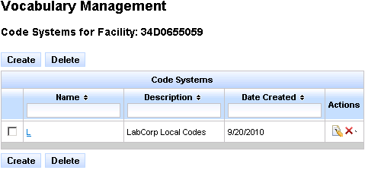

Figure 25. Setting a Code Systems for a Facility

### Add a Code System

1. Click on the Create button.
2. Enter the Name and description for the code system in the Add New Code System window.
3. Click Create. The code is added.

### Edit a Code System

1. Click on the edit icon (note pad/pencil) under Actions.
2. Edit the necessary information in the Edit Current Code System window.
3. Click Update. The code is updated.

### Delete a Code System

1. Click on the delete icon (red **X**) under Actions to delete one code system at a time.

**Note:** To delete several code systems at one time, check the box next to all the code systems to be deleted and then click the Delete button.

1. Click Yes in the Delete confirmation window.
2. The code system(s) are deleted.

### Import a Code System

You can import a code system using the All Code Systems link from the Vocabulary folder within the Validations or Translations bar in the Navigation Pane.

**Note:** The file being imported must be Tab Delimited-Separated Values text file ending in .txt. The file cannot be larger than 1 MB (approximately 50,000 lines). The system will return an error and terminate the import process if the file is too large.

1. Click the **All Code Systems** link under the *Vocabulary* folder in the *Validations* or *Translation* bar.

MSS displays the *All Code Systems* page.

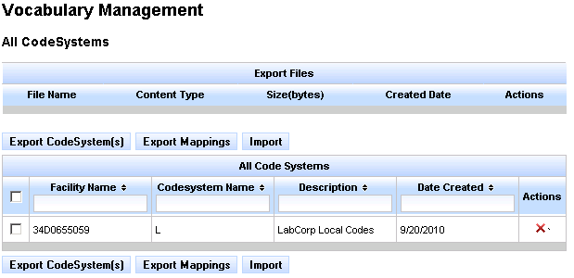

Figure 26. Import a Code System Screen

1. Click Import.
2. Click Select File button in the Import Code systems window and navigate to the file you want to import.
3. Click Import Code Systems (s).

### Export a Code System

You export code systems using the All Code Systems link from the Vocabulary folder within the Validation or Translation bar of the Navigation Pane.

**Note:** To successfully export a code system, it must contain a minimum of one code.

1. Click the **All Code Systems** link under the *Vocabulary* folder in the *Validations* or *Translation* bar. MSS displays the *All Code Systems* page.



Figure 27. All Code Systems Screen

1. Select one of the two export options:

* Click the Export Code Systems button to export only the selected Facilities, Code Systems, and Codes.
* Click the Export Mappings button to export the selected Facilities, Code Systems, Codes, and any associated mappings.

1. Click the checkbox for the code system(s) you wish to export.
2. Click Export button.
3. Click Yes in the Export confirmation window.

## 

## Code Management

You can use the code management system to manage the view, edit and delete codes.

### View Codes

To access code systems, Click the Validations or Translation bar in the navigation pane. Open the Vocabulary folder and click the Facilities link to display the Facilities page. From the Facilities page, click on the facility link and then select link for the code system to be displayed. MSS displays the codes for the selected Code System. (e.g. L for local code system)

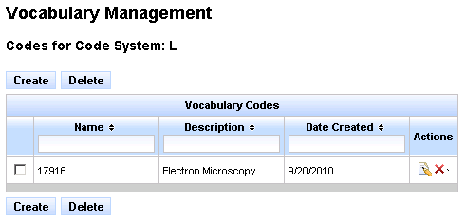

Figure 27. View Codes for Code System Screen

### Add Codes

1. Click on the Create button.
2. Enter the Name and description for the code in the Add New Code window.
3. Click Create.

### Edit Codes

1. Click on the edit icon (note pad/pencil) under Actions.
2. Edit the necessary information in the Edit Current Code window.
3. Click Update.

### Delete Codes

1. Click on the delete icon (red **X**) under Actions to delete one code at a time.

**Note:** To delete several codes at one time, check the box next to all the codes to be deleted and then click the Delete button.

1. Click Yes in the Delete confirmation window.
2. The code(s) are deleted.

## Code Mapping

Within MSS, you can map standard codes to standard codes, local codes to standard codes, and local codes to local codes.

### View Code Mapping

To view existing lists of code mappings, select the Translation bar in the navigation pane; then select the Vocabulary folder. Click on the Mapped Codes link from the Vocabulary folder.

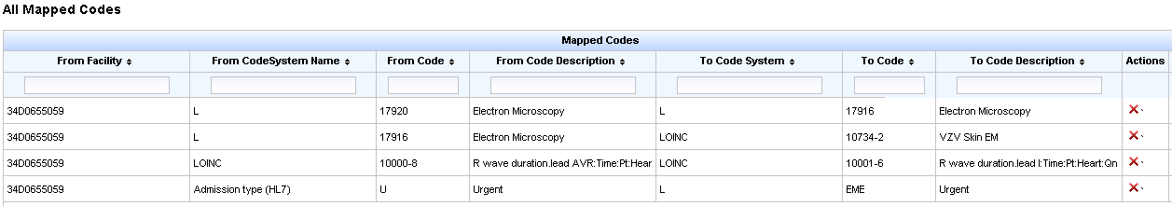

Figure 28. View Mapped Codes Screen

### Map a Code

To map a code, select the Translation bar in the navigation pane; then select the Vocabulary folder. Click on the Map Codes link from the Vocabulary folder to access the Code Mapping screen.

**Note:** The facility, code system and codes to be mapped must be set up in MSS before codes can be mapped to another code system.

**Remember:** Always click the *Update Translation Services* link after making changes in the validation service configurations.

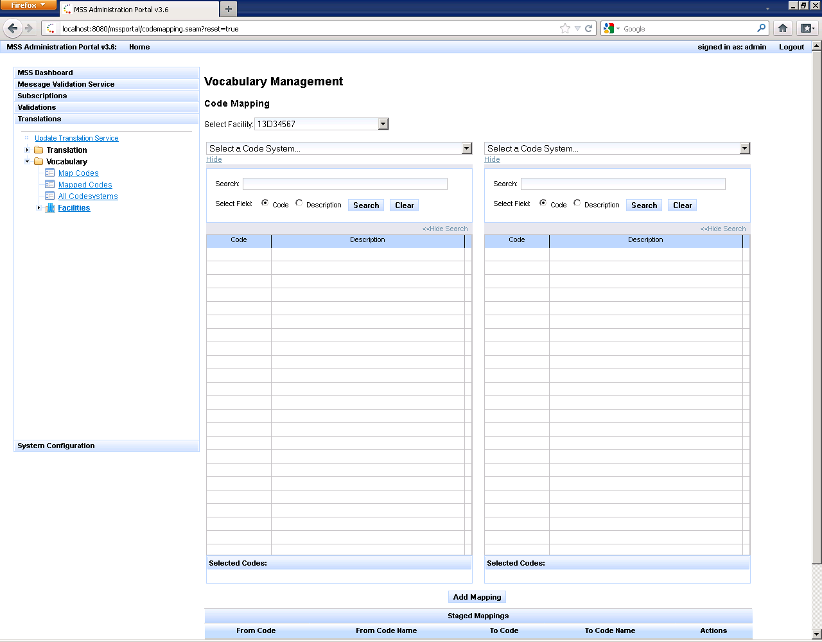

Figure 29. Code Mapping Screen

1. Click on the *Select Facility* dropdown and choose the Facility where the codes to be mapped are located.
2. Click in the *Select a Code System* (left side) dropdown and select the code system that contains the codes to be mapped.

The system will display the list of codes associated with the selected code system with search options to filter by code or description.

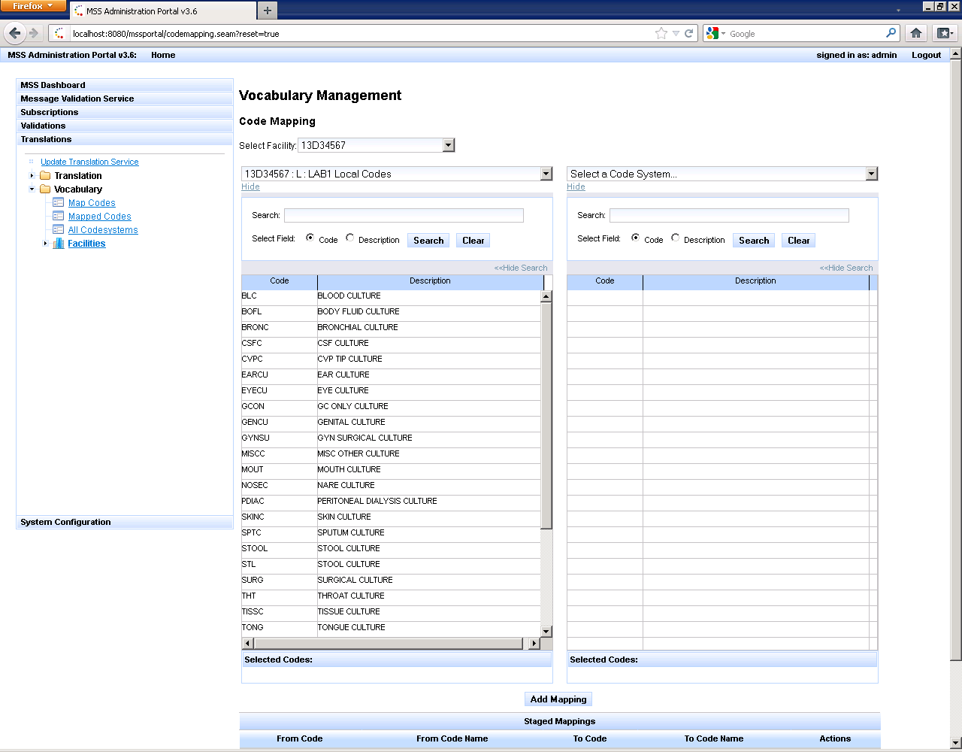

Figure 30. Display of Codes based on Search Options

1. Select a code from the list.

The system will display the code in the Selected Codes area below the code list.

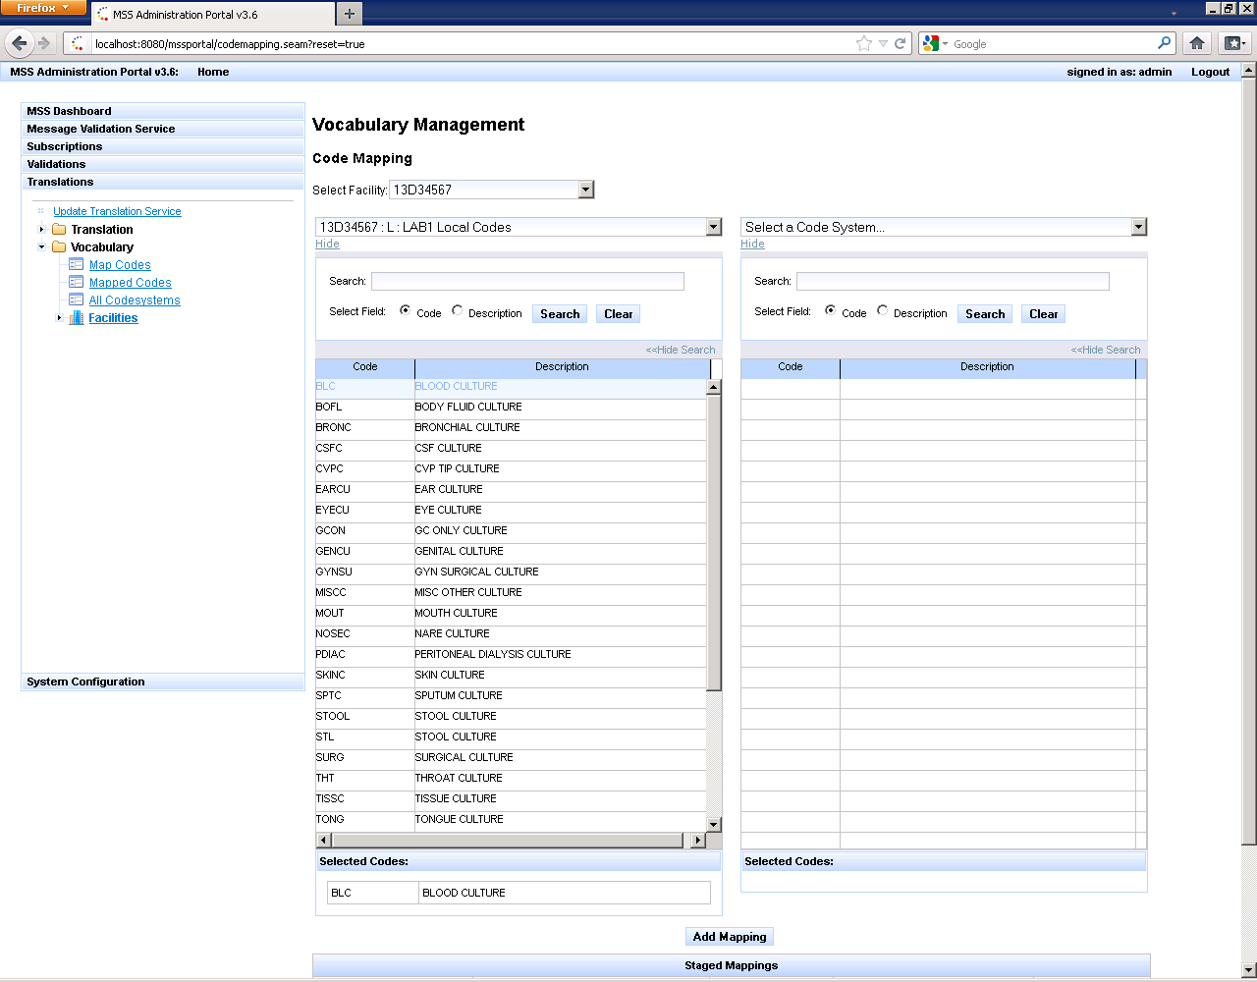

Figure 31. Display of Codes based on Selected Codes

1. Click in the *Select a Code System* (right side) dropdown and select the code system that contains the codes where the codes will be mapped. For this example, select the LOINC code system.

The system will display the list of codes associated with the selected code system with search options to filter by code or description.

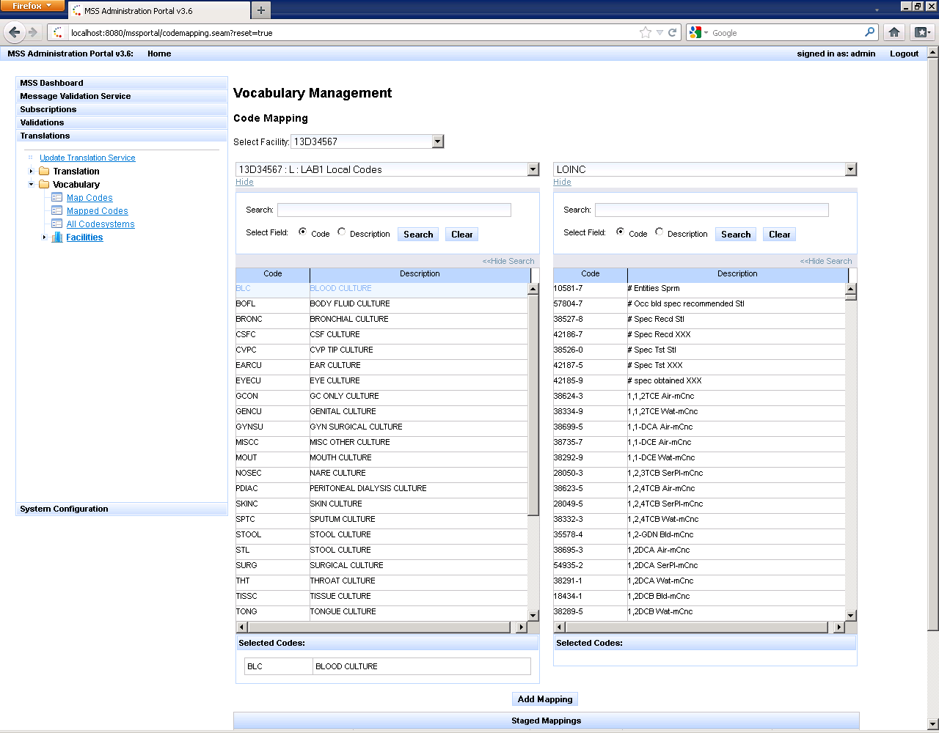

Figure 32. Display of Codes based on Selected Codes with Search Options Filter

1. Enter the code in the *Search* box; then click the Search button.

**Note:** The radio button for Code must be selected to filter by code. Click the radio button next to description to filter by description.

1. Select the code that was returned from the search.

The system will display the code in the Selected Codes area below the code list.

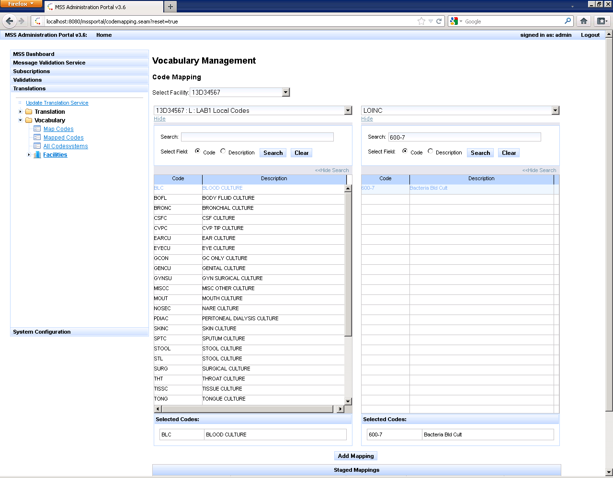

Figure 33. Display of Code Selection

1. Click on the Add Mapping button.

The code mapping is displayed in the **Staged Mappings** table at the bottom of the page.

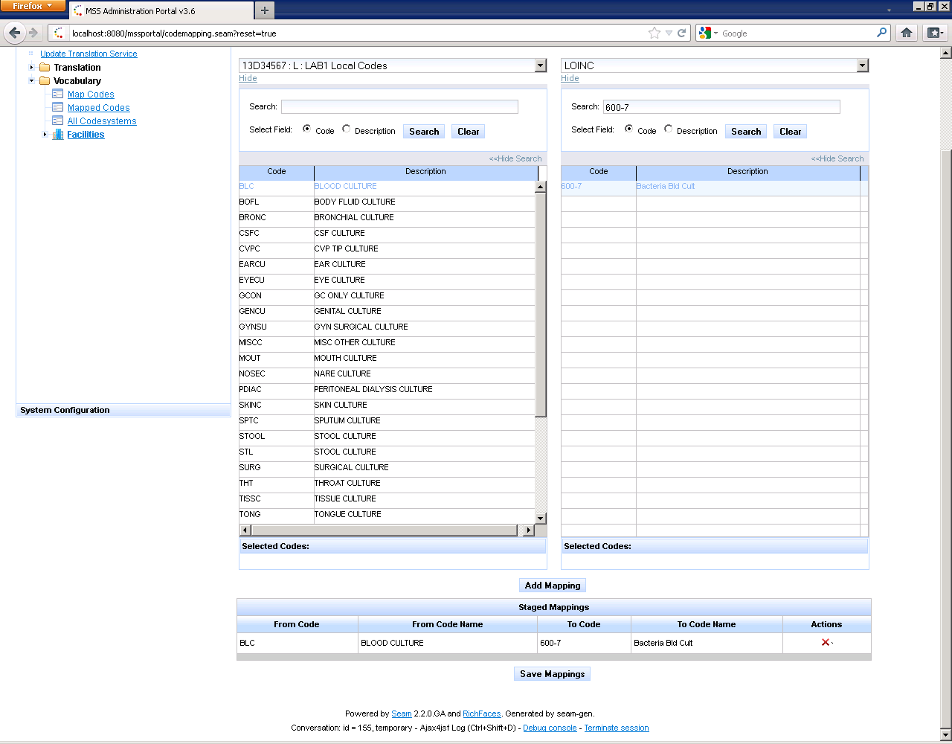

Figure 34. Staged Mapping Table

1. Select Save Mapping button.

Note: The system saves the mapping and displays Mapping Saved Successfully. Repeat these steps to map additional codes.

### Delete a Code Map

Display the listing of mapped codes by selecting the Translation bar in the navigation pane; then select the Vocabulary folder. Click on the Mapped Codes link from the Vocabulary folder.



Figure 35. Display of All Mapped Codes

1. Click on the delete icon (red **X**) under Actions to delete code mapping.
2. Click Yes in the Delete confirmation window.
3. The mapping is deleted.

## Vocabulary Translation

Vocabulary Translation function provides the capability to perform code translation tasks to allow mapping between vocabularies and mapping of local codes to standard codes.

### Configure the Translation Profile

The Translation Profile details what fields should be translated, as well as other optional configurations, such as the location of the Facility ID and whether the translated code system should use the short name. You must create a Translation Profile before you create the translation rules.

1. Expand the *Translation* folder and click the Profile link in the *Navigation Pane*.
2. Select the Create button.
3. Enter the Name and description for the validation profile in the Add a Profile window.
4. Click Create. The Translations profile is created.

MSS displays the **Rule Configurations** window.

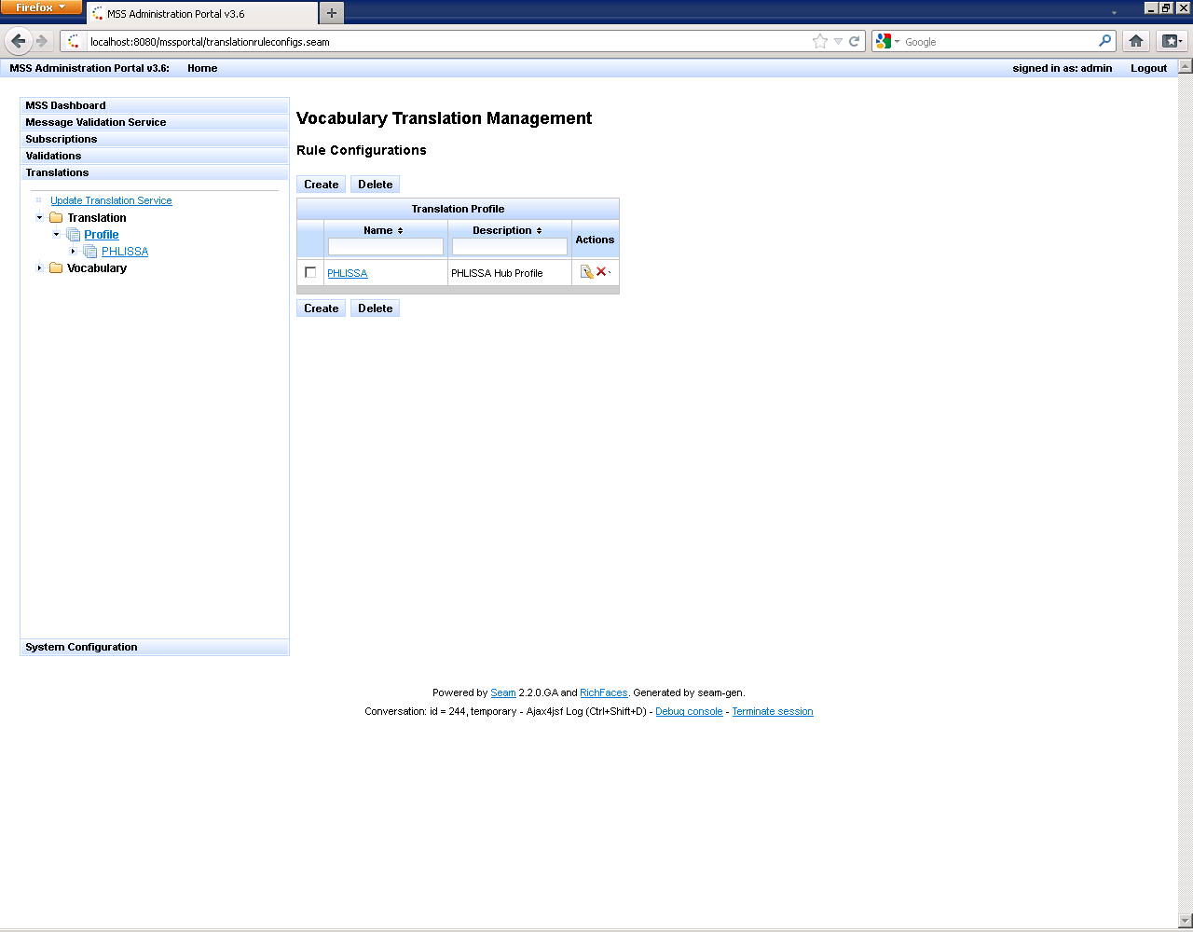

Figure 36. Rules Configurations Screen

1. Click on the link for the Translation Profile you created.

MSS displays the **Rule for Profile** window.

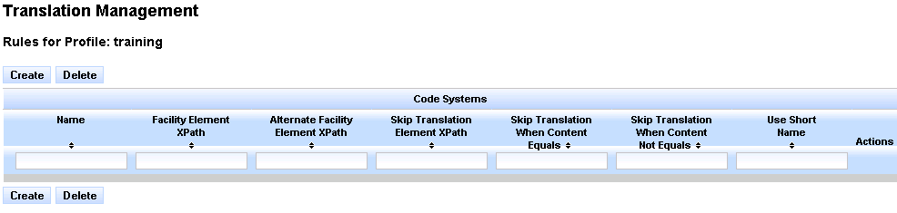

Figure 37. Rules for Profile Screen

1. Click on the Create button.

MSS displays the Add New Rule window. The translations rule for obx3 is created for the demonstration.

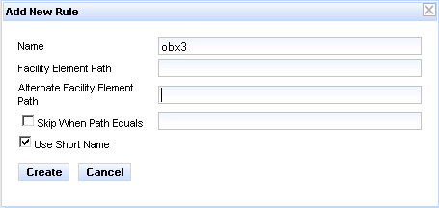

Figure 38. Add New Rule Screen

1. Enter the following information in the fields.

* Type **obx3** in the Name text box.
* Check the **Use Short Name** checkbox.

1. Click Create.

MSS displays the Rules for Profile window.

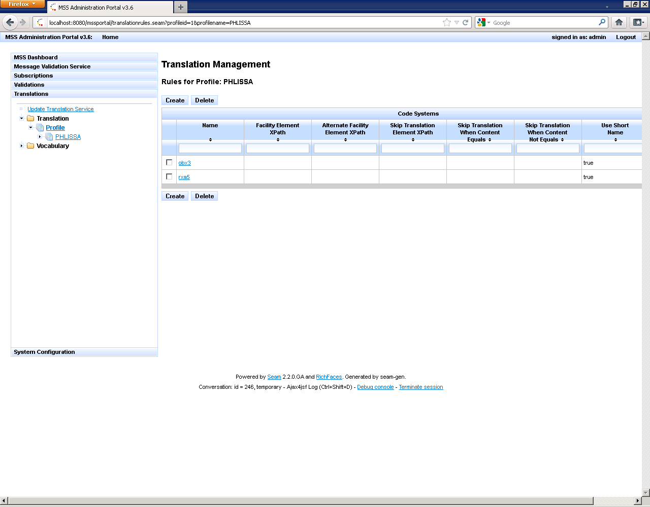

Figure 39. Display of the Profile Window

1. Click on the link for the rule you created.

MSS displays the Elements for Rule window.

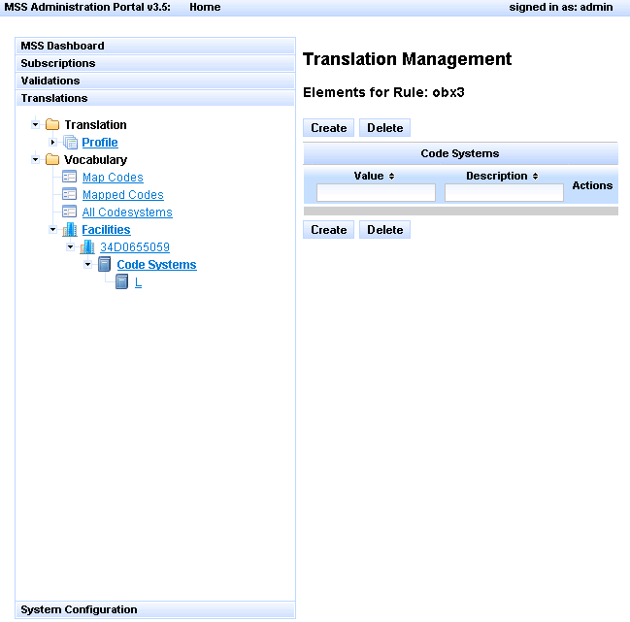

Figure 40. Display of the Rule Elements

1. Click on the Create button.
2. Enter the Value and description in the Add New Element window.

Note: The value is the XPath for the field to be translated

1. Click Create. The element is added.

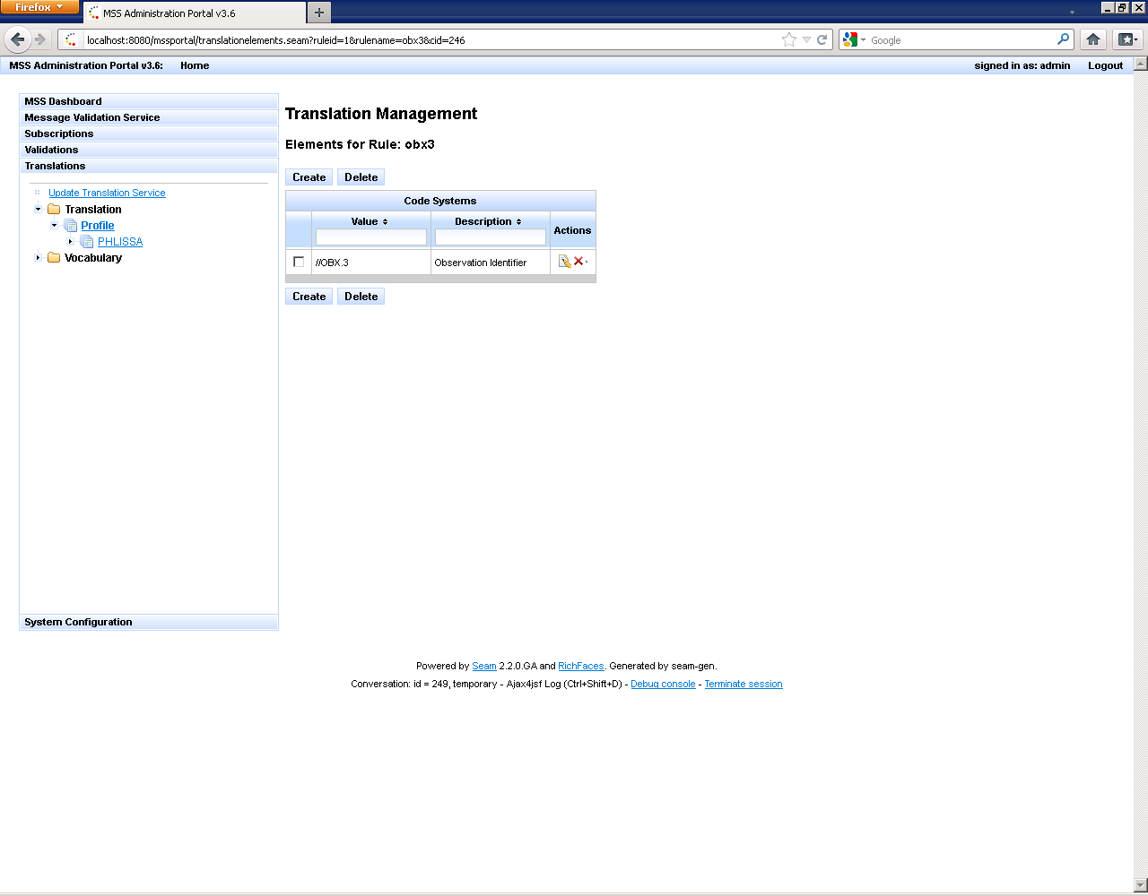

Figure 41. Confirmation of the Element Addition

## Vocabulary Validation

Vocabulary Validation function provides the capability to perform field-level validation tasks and validate message elements against a code systems and/or a value sets maintained by PHIN VADS.

**Important:**  The following prerequisites must be met before you can configure vocabulary validations services.

* Must have a working PHIN VADS connection configured in PhinVS.xml file.
* Must have a completed import of the PHIN VADS database content
* Must have a set of fully defined business rules for validation.
* The person configuring the vocabulary validations must have knowledge of XML and XPaths.

**Remember:** Always click the *Update Validation Services* link after making changes in the validation service configurations.

### Create XPath Profile

The Map Field To XPath profile contains the location to of specific field in an HL7 or XML message

1. Click the Validations bar
2. Expand the *Map Field To XPath* folder and click the **Profiles** link in the *Navigation Pane*.

MSS displays the Map Field To XPath profile list.

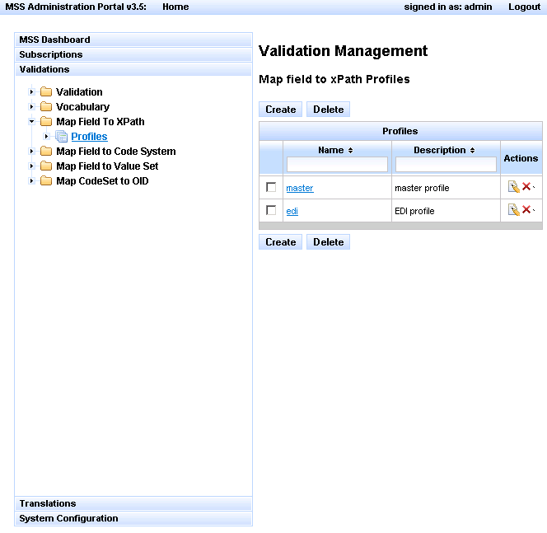

Figure 42. Map Field to xPath Profile Screen

1. Click on the Create button.
2. Enter the Name and description for the validation profile in the Add a Profile window.
3. Click Create. The profile is created.

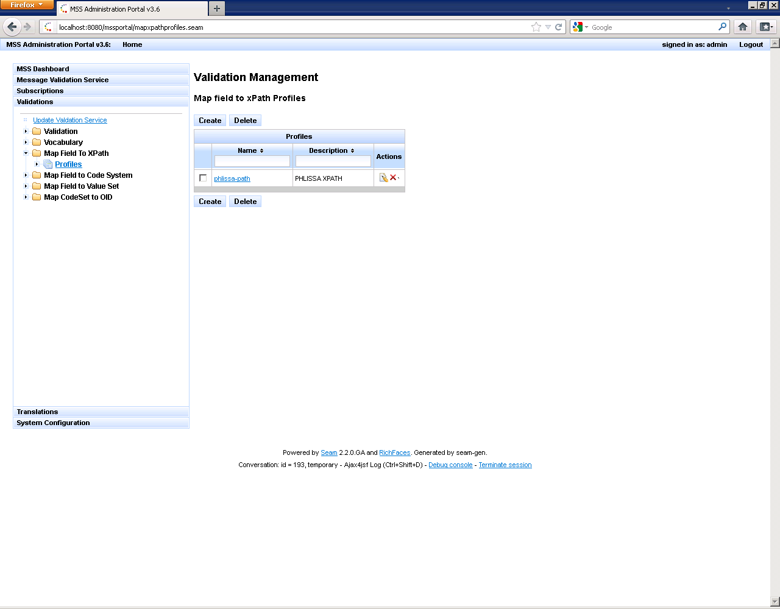

Figure 43. Map Field to xPath Profile Confirmation Screen

### Configure Map Field to XPath Profile

The Map Field To XPath profile contains the location to of specific field in an HL7 or XML message.

1. Click the Validations bar
2. Expand the *Map Field To XPath* folder
3. Click the **Profiles** link in the *Navigation Pane*.
4. Click on the link for the XPath profile you created.

MSS displays the Map XPath Keys for profile window

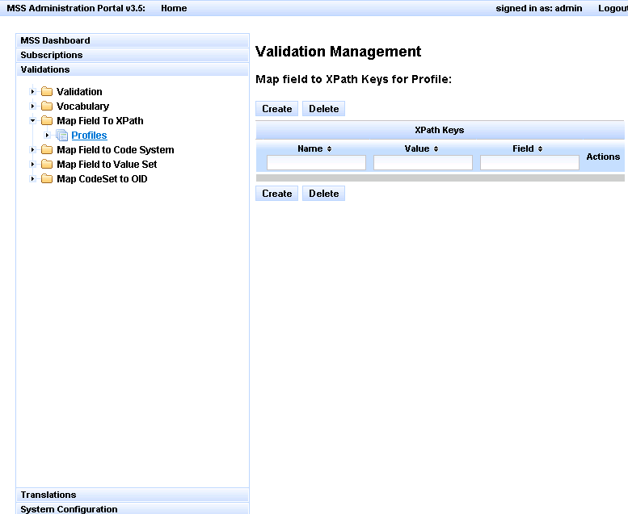

Figure 44. Display of XPath Keys for Profiles

1. Click on the Create button.
2. Enter the required information in the Add New Key window.

**Note:** The XPath for OBX-3.l is created for this demonstration.

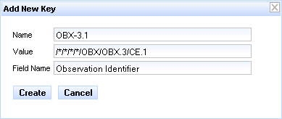

Figure 45. Display of New XPath Key

1. Click Create. The XPath Profile is created.

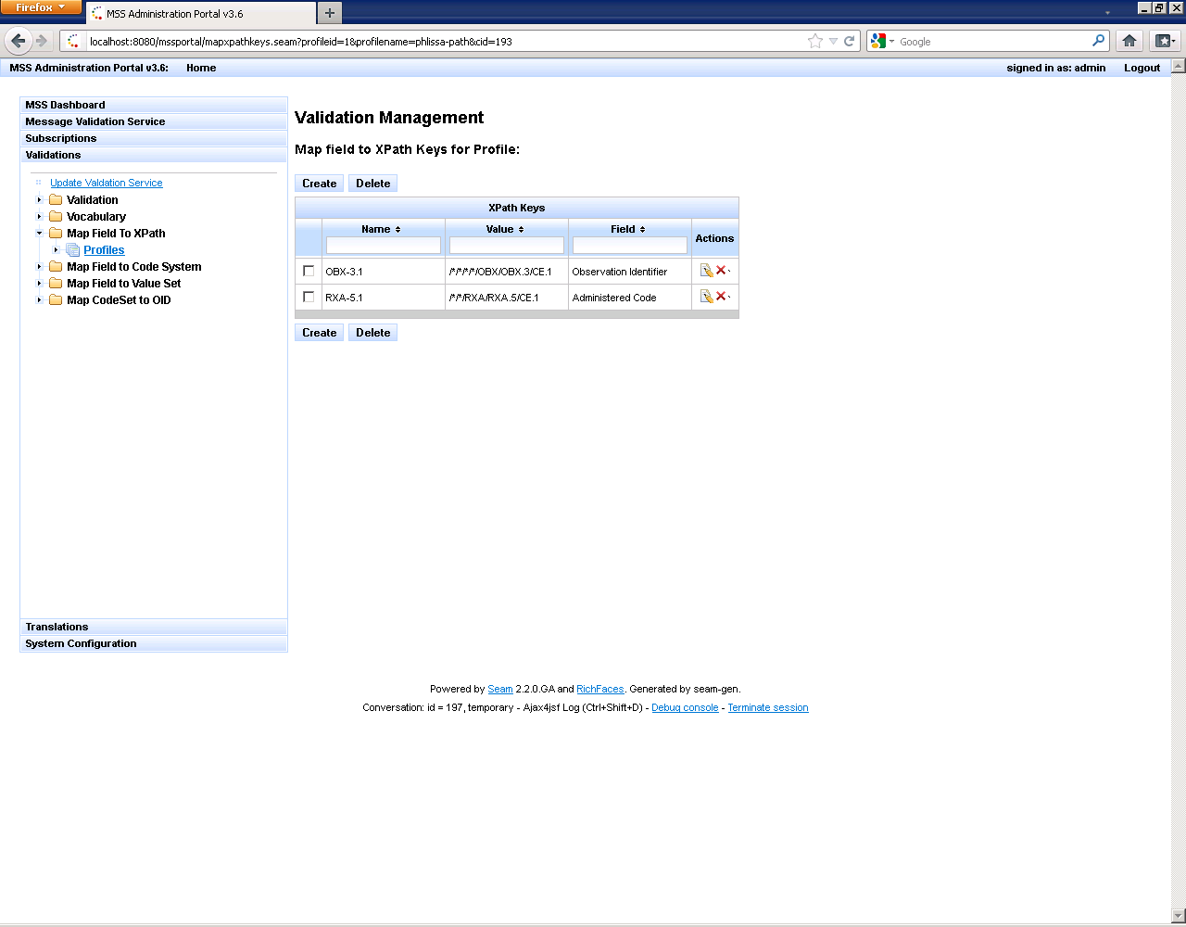

Figure 46. Display of New XPath Profile

### Create Map Field to Code System Profile

1. Click the Validations bar
2. Expand the *Map Field To Code System* folder and click the **Profiles** link in the *Navigation Pane*.

MSS displays the Map Field To Code System profile list.

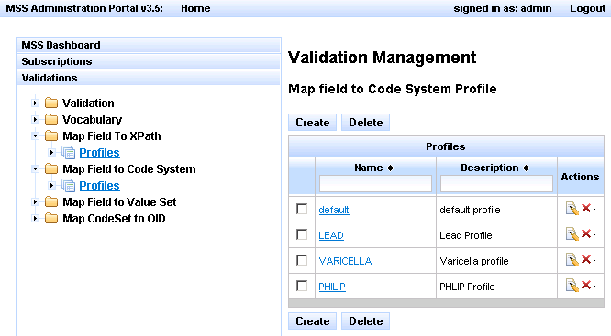

Figure 47. Display of Map Field to Code System Profile

1. Click on the Create button.
2. Enter the Name and description for the code system profile in the Add a Profile window.
3. Click Create. The profile is created.

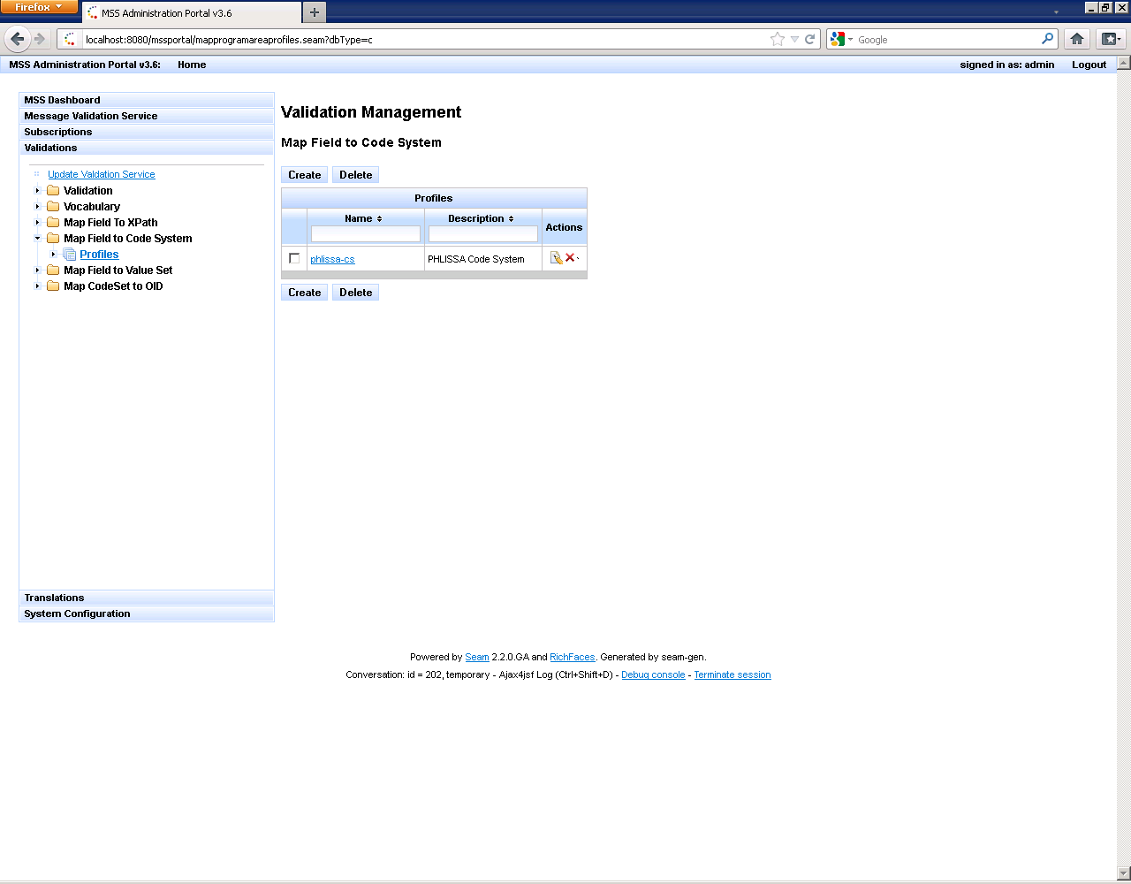

Figure 48. Validation of Map Field to Code System Profile

### Create Map to Code System Profile

The Map Field To Code System profile contains all current code system mappings from a specific field in an HL7 or XML message to a standard or local code system and defines these mappings in the profile keys.

1. Click the Validations bar
2. Expand the *Map Field To Code System* folder
3. Click the **Profiles** link in the *Navigation Pane*.
4. Click on the link for the code System profile you created.

MSS displays the Map Field to Code System Keys window

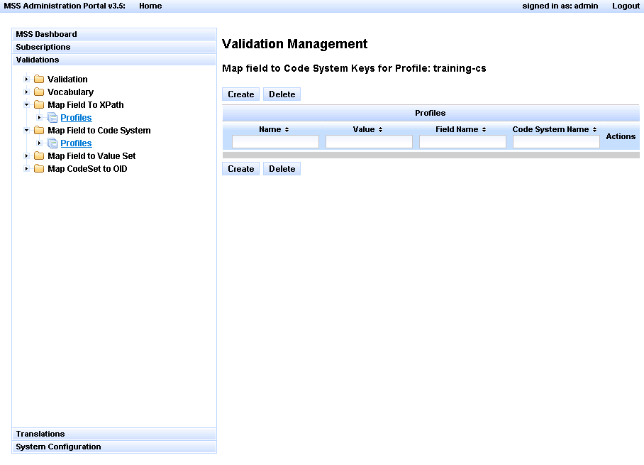

Figure 49. Map Field to Code System Keys Screen

1. Click on the Create button.
2. Enter the required information in the Add New Key window:

**Note:** The Code System for OBX-3.1 is created for this demonstration.

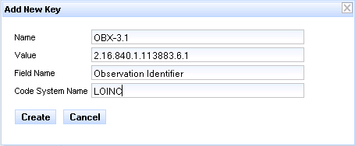

Figure 50. Add New Key Screen

1. Click Create. The Map Field to Code System Profile is created.

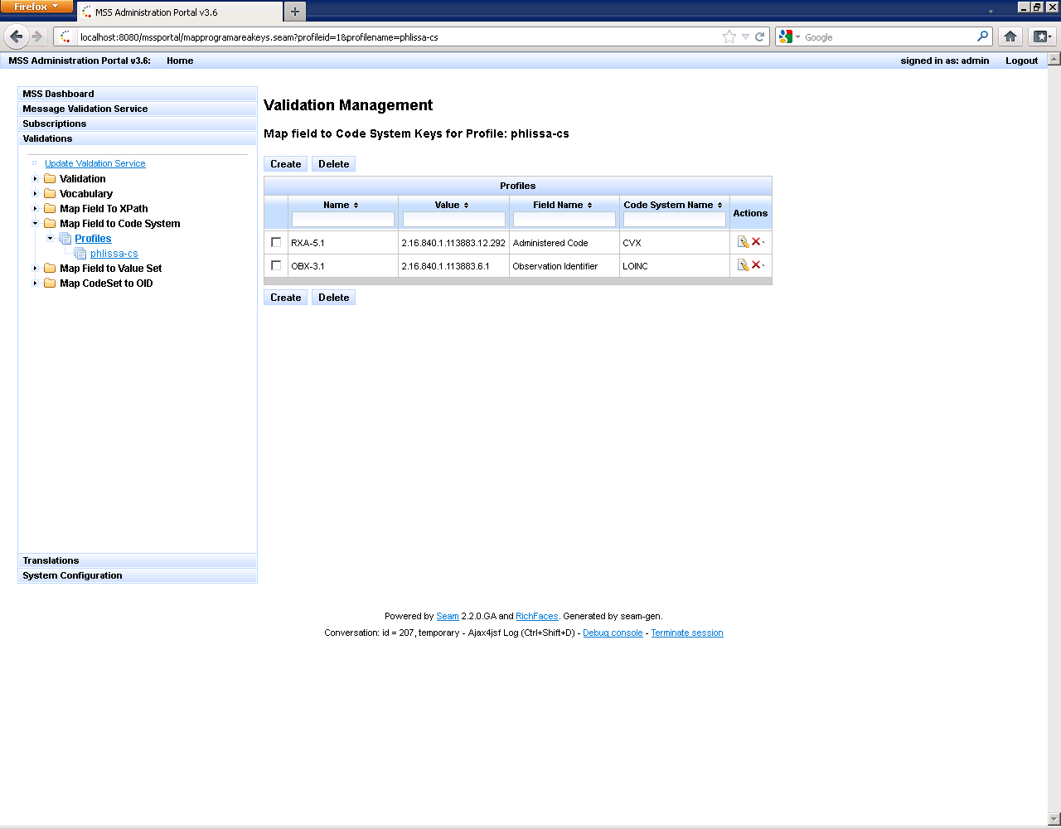

Figure 51. Display of Map Field to Code System Profile

### Configure Validation Profile

You must create a Validation Profile before you create the validation rules.

1. Click on the Validation bar in the Navigation pane.
2. Click on the Validation folder.
3. Click on the Profiles link.
4. Select the Create button.
5. Enter the Name and description for the validation profile in the Add a Profile window.
6. Click Create. The Validation profile is created.

MSS displays the **Rule Configurations** window

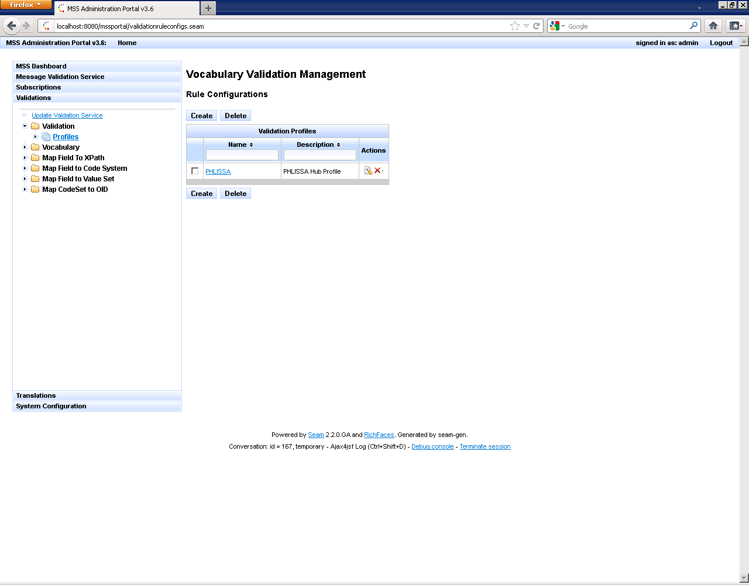

Figure 52. Display of Rule Configurations Screen

1. Click on the link for the Validation Profile you created.

MSS displays the Rules for Profile window.

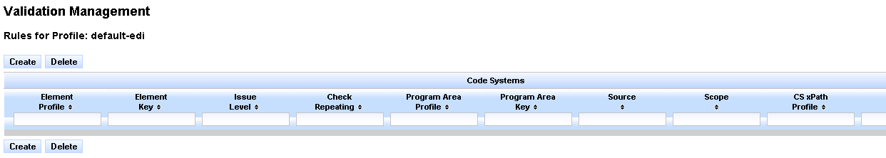

Figure 53. Rules for Profile Screen

1. Click on the Create button.

MSS displays the **Add new Rule** window.

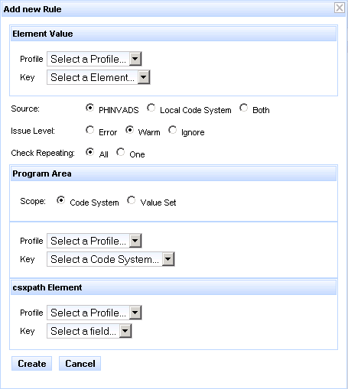

Figure 54. Add New Rule Screen

**Note:** To validate against a Code System or Value Set, you must: define the validation rules for the field to be validated, code system/value set used to validate the value within a field and the location of the field. This is a demonstration of the configurations for validating against a Coding System.

1. Select the following information for the elements values in the Add New Rule window:

**Note:** Rules for OBX-3 will be created for this demonstration

* Select **phlissa-path** (name of the XPath profile you created) from the *Element Value Profile* drop down.
* Select **OBX-3.1** from the *Element Value Key* drop down.
* Select **PHINVADS** for the *Source* option.
* Select **Error** for the *Issue Level* option.
* Select **All** for the *Check Repeating* option.
* Select **Code System** for the *Program Area Scope* option.
* Select **phlissa-cs** (name of the Code system profile you created) from the *Program Area Profile* drop down.
* Select **OBX-3.1** from the *Program Area Key* drop down.

1. Click Create.

MSS adds the rule to the profile.

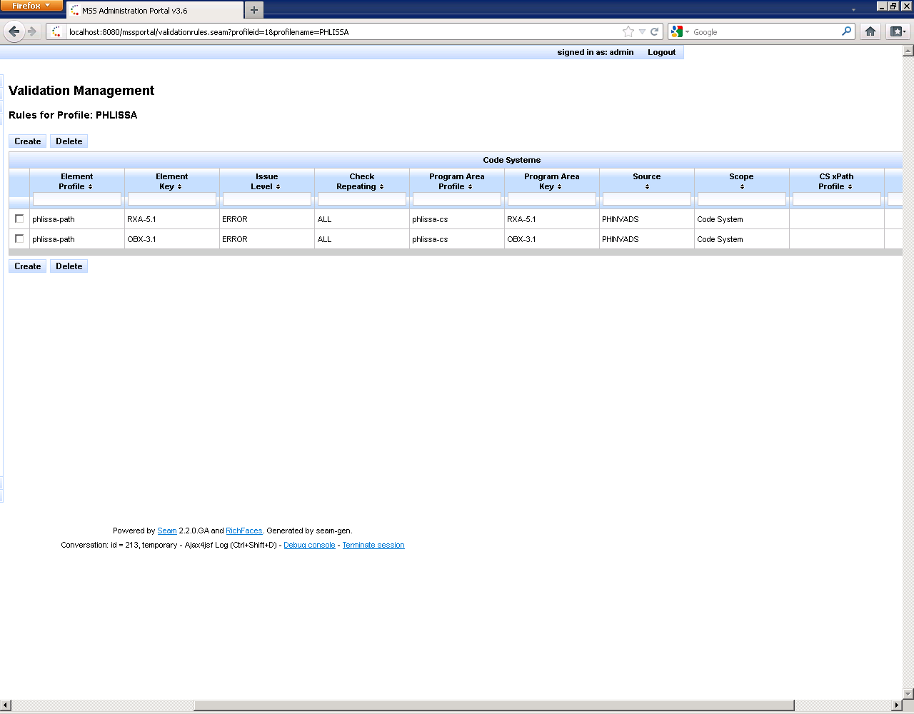

Figure 55. Confirmation Screen for New Rule

## Message Subscription

Message Subscription function provides the capability to perform message routing tasks based on criteria specified to direct when and where messages are delivered.

### Add a Subscriber

1. Click on the Subscriptions bar in the Navigation pane.
2. Expand the *Subscription Management* folder and click **Subscribers.**

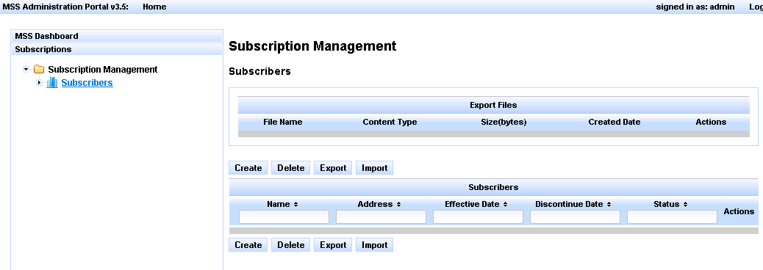

Figure 56. MSS Subscriber List Home Page

1. Click the Create button.
2. Enter the Subscriber Name and Address in the Add New Subscriber window.
3. Click Create. The subscriber is added to the Subscriber list.

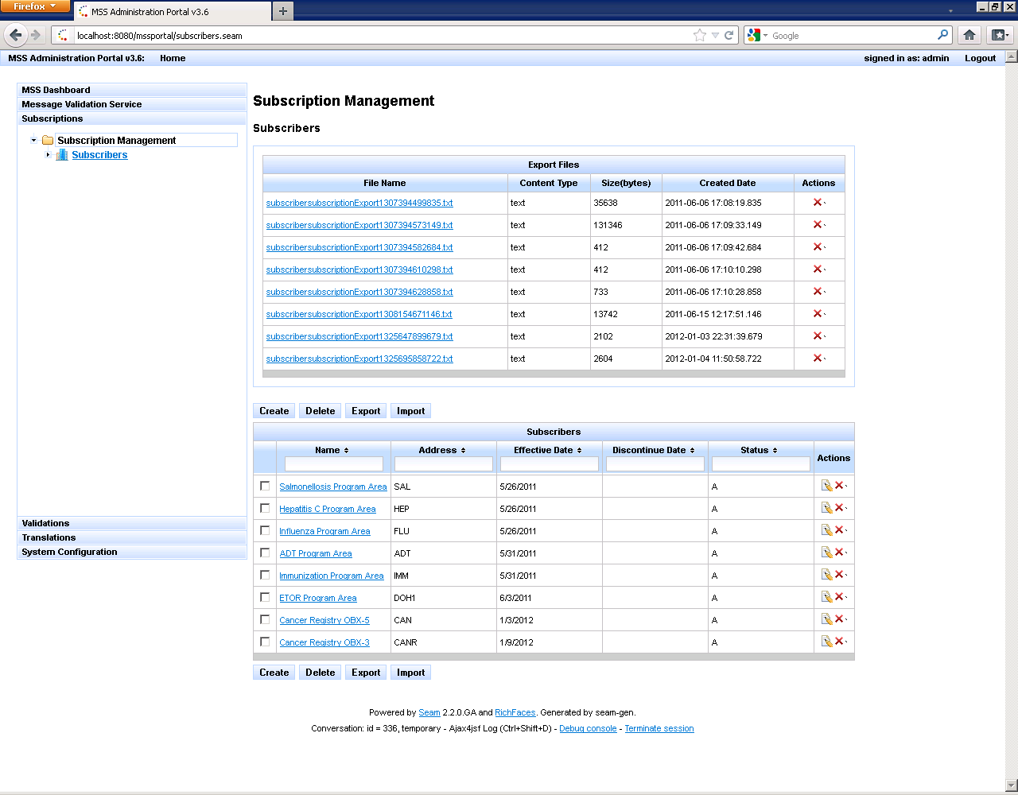

Figure 57. Updated MSS Subscriber List

### Edit Subscriber

1. Click on the edit icon (note pad/pencil) under Actions.
2. Edit the necessary information in the Edit Subscriber window.
3. Click Update.

### Edit Subscriber

1. Click on the delete icon (red **X**) under Actions to delete one subscriber at a time.

**Note:** To delete several subscribers at one time, check the box next to all the subscribers to be deleted and then click the Delete button.

1. Click Yes in the Delete confirmation window. The subscriber(s) are deleted.

### Add a Subscription

1. Click on the Subscriptions bar in the Navigation pane.
2. Expand the *Subscription Management* folder and click **Subscribers.**
3. Click on the name of the Subscriber

MSS displays the *Create Subscription* window

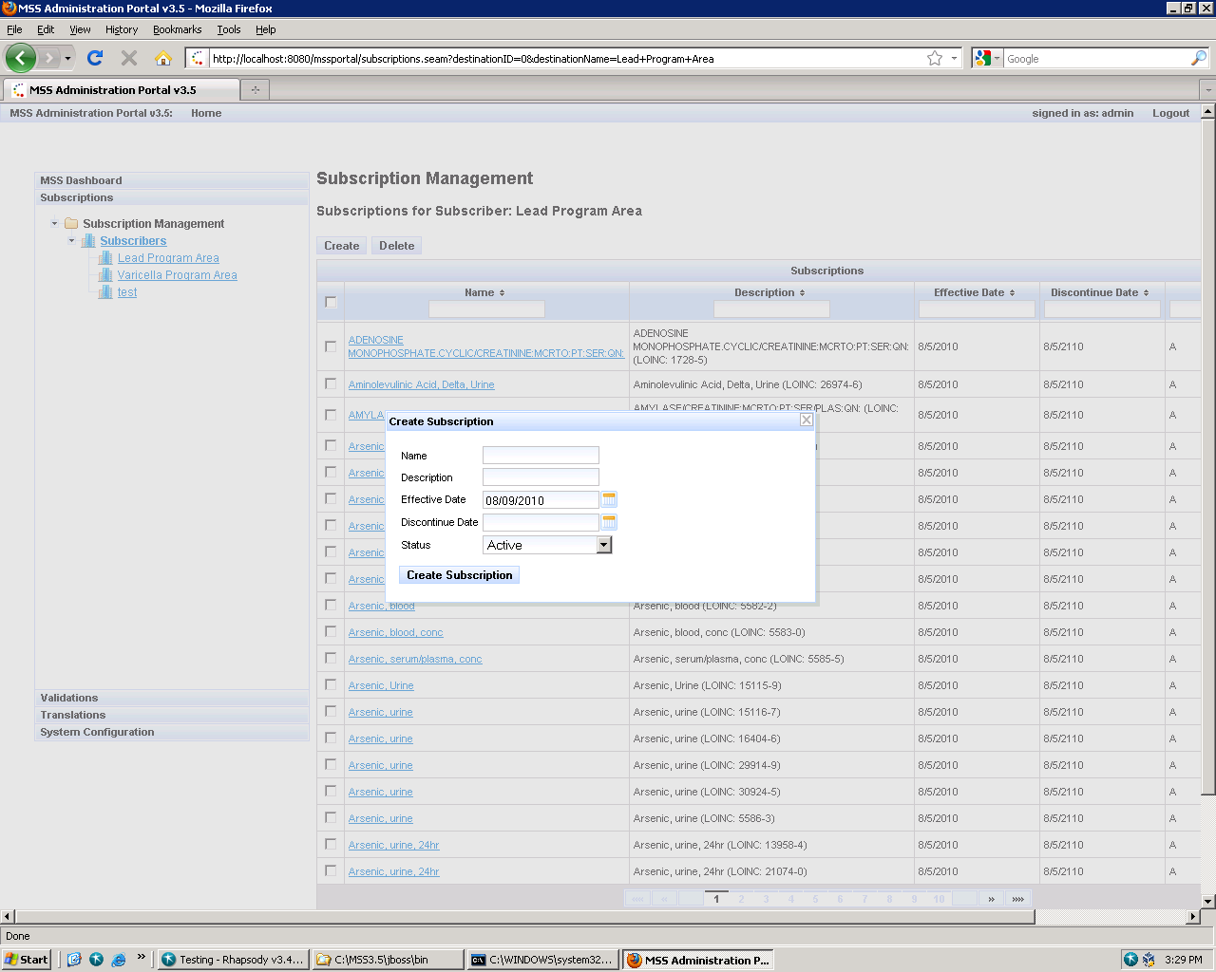

Figure 58. Create Subscription Screen

1. Enter the Subscription Name and Description
2. Click Create Subscription. The subscription is added to the list.

### Add Subscription Criteria

1. Click on the link for the Subscription that you created.

MSS displays the subscription criteria page.

1. Click on the Create button.

MSS displays the subscription criteria options.

**Note:** Criteria for testing the value in OBX-3/OBX-5 combination are demonstrated in this example.

1. Select the following criteria for OBX -3:

* Select Lab Test (OBX-3) in the *Condition* list
* Select **Standard Code (CE.1)** in the *Occurrence* list.
* Select **Equals** in the *Operator* list.
* Select **LOINC** in the *Code System* list.
* Type **600-7** in the *Code* filter text box.
* Select **600-7** from the list

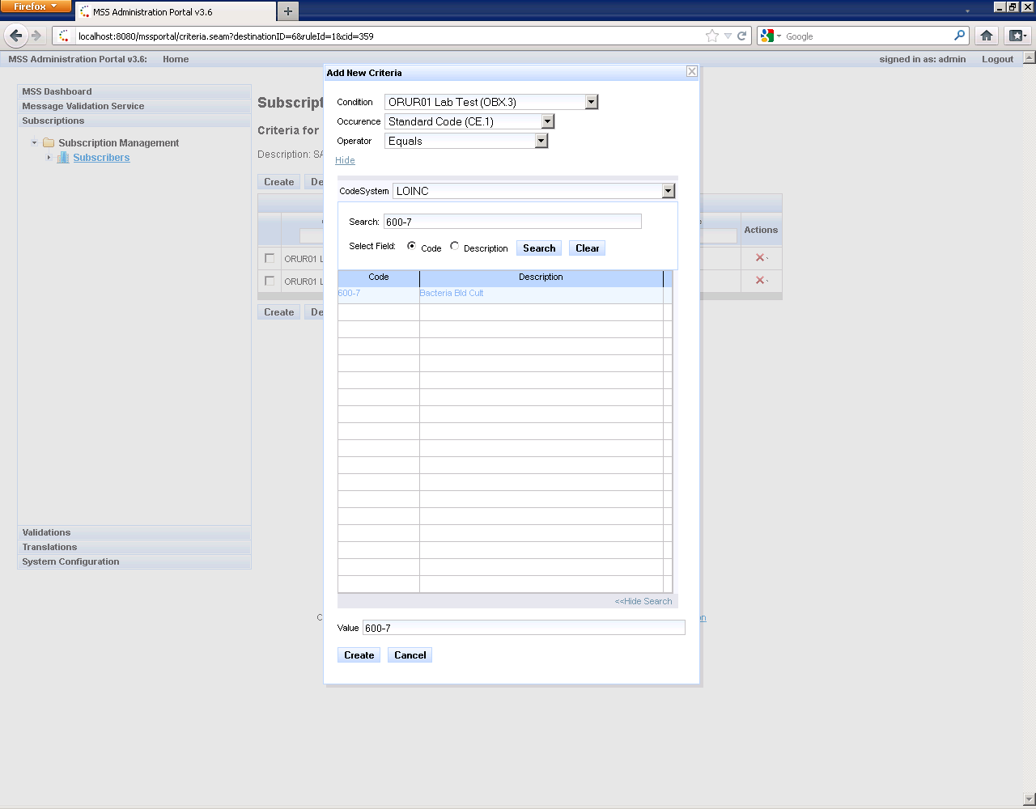

Figure 59. Add Subscription Criteria Screen

1. Click Create. The subscription criteria for OBX-3 is created
2. Click on the Create button.
3. Select the following criteria for OBX -5:

* Select Lab Test (OBX-5) in the *Condition* list
* Select **Standard Code (CE.1)** in the *Occurrence* list.
* Select **Equals** in the *Operator* list.
* Select **SNOMED-CT** in the *Code System* list.
* Type **5595000** in the *Code* filter text box.
* Select **5585000** from the list

1. Click Create. The subscription criteria for OBX-5 is created

MSS displays the criteria created to validated this rule as an AND statement; whereas, this will be considered a match if both OBX-3 and OBX-5 conditions are met.

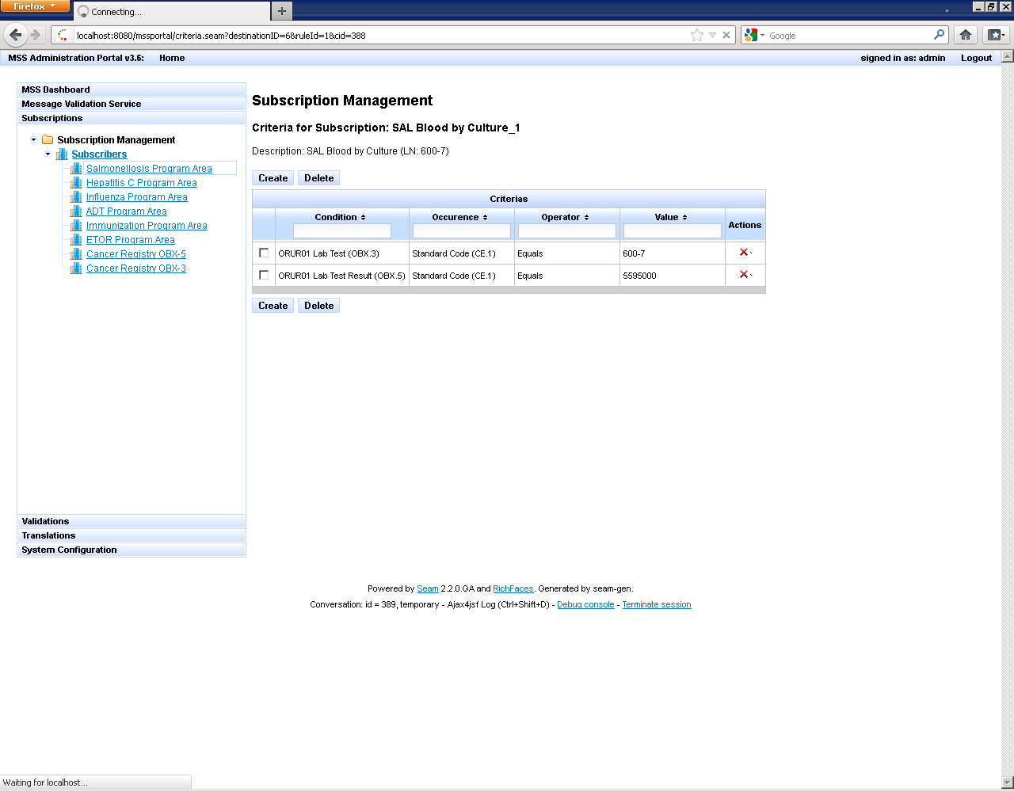

Figure 60. Verify Subscription Criteria Screen

**Note:** Criteria can be created using different types of Operators and values.

### Subscription Criteria Examples

1. Example #1 – Coded Values

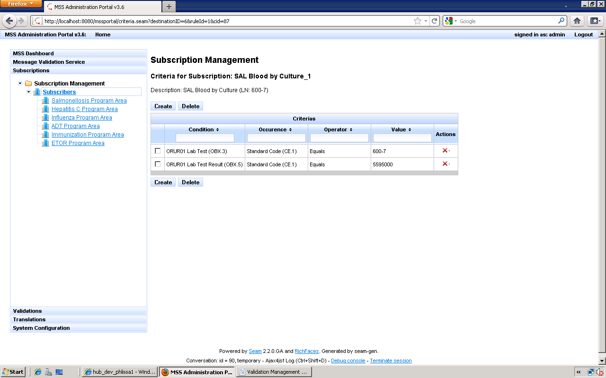

Figure 61. Subscription Criteria Coded Values

1. Example #2 – Structured Numeric Values

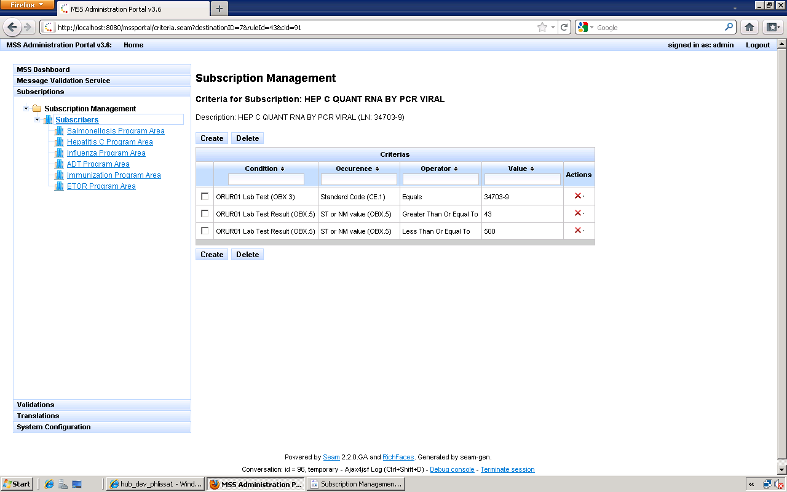

Figure 62. Subscription Criteria Structured Numeric Values

1. Example #3 – Structured Numeric Values

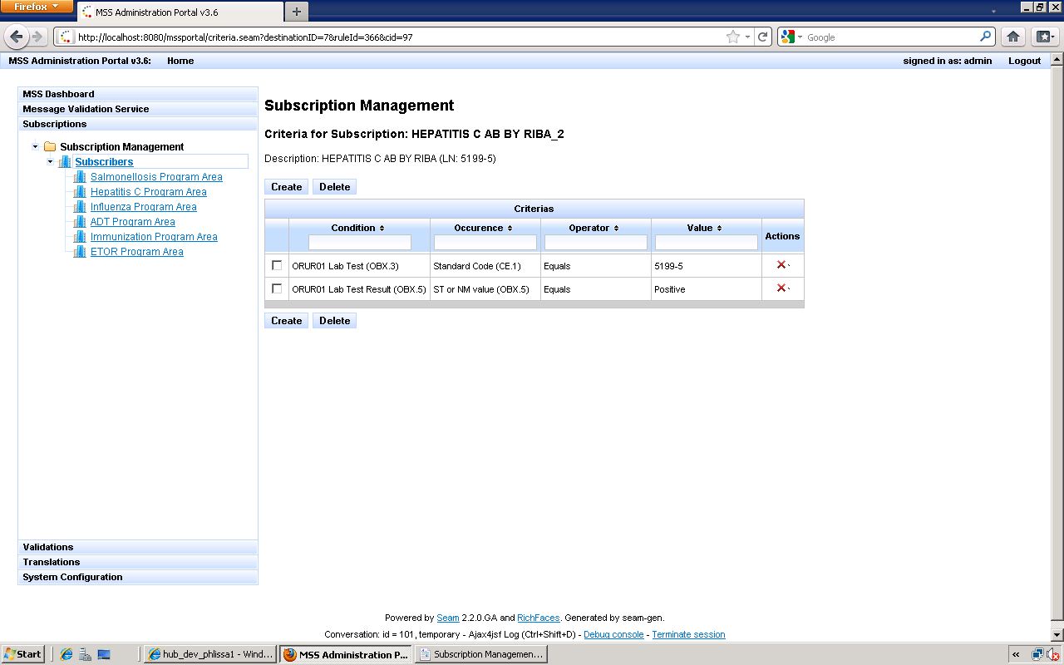

Figure 63. Subscription Criteria for String Values

### Edit Subscription

1. Click on the edit icon (note pad/pencil) under Actions.
2. Edit the necessary information in the Edit Subscription window.
3. Click Update.

### Delete Subscription

1. Click on the delete icon (red **X**) under Actions to delete one subscription at a time.

**Note:** To delete several subscriptions at one time, check the box next to all the subscriptions to be deleted and then click the Delete button.

1. Click Yes in the Delete confirmation window. The subscriptions (s) are deleted.

### Import Subscriptions

You can import subscriptions from the Subscribers or Subscription page.

**Note:** The file being imported must be Tab Delimited-Separated Values text file ending in .txt. The file cannot be larger than 1 MB (approximately 50,000 lines). The system will return an error and terminate the import process if the file is too large.

1. Click on the Subscriptions bar in the Navigation pane.
2. Expand the *Subscription Management* folder and click **Subscribers.**
3. Click Import button.
4. Click Select File and navigate to the file you want to import.
5. Click Import Subscription (s).

### Export Subscriptions

You can import subscriptions from the Subscribers or Subscription page.

**Note:** To successfully export a subscription, it must contain a minimum of one subscription.

1. Click on the Subscriptions bar in the Navigation pane.
2. Expand the *Subscription Management* folder and click **Subscribers.**
3. Select one of the two export options:

* To export a single subscription, click the subscriber link for the Subscriber that contains the subscription you wish to export.
* To export all subscriptions assigned to a subscriber, displays the *Subscriber* List page.

1. Click the checkbox for the subscriber or subscriptions you wish to export.
2. Click the Export button.
3. Click Yes in the Export confirmation window.

MSS saves the file to the database and displays the export file in the export table.

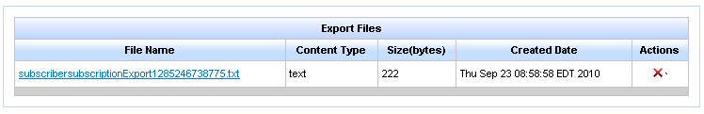

Figure 64. Export Subscription Display Screen